PROJECT REPORT FOR SAU AWARD
TO BE SUBMITTED ONE YEAR FROM DATE OR RECEIPT OF AWARD

Alter the form as needed for spacing answers, but please duplicate
the form’s format and language
Please submit to Ben Johnson (Slot #35, bfjohnson@saumag.edu) both a Microsoft Word email attachment and a hard copy.

1. NAME OF AWARD RECIPIENT: ( Include title and department )
Ganna Lyubartseva
Assistant Professor of Chemistry
Department of Biochemistry, Chemistry and Physics

2. TITLE OF PROJECT:
Synthesis and Characterization of Transition Metal Thiocyanate Complexes with Tris(pyrazol-1-yl)methane

3. SUMMARY OF WORK ACCOMPLISHED:
Based on our results, SAU undergraduate student Hee Kyung Jeon presented a poster at the Arkansas Academy of Science 96th Annual Meeting, 2012.
We also published a peer-reviewed article (Acta Crystallographica 2012, E68, m888).
Tris(pyrazol-1-yl)borate has been used to structurally mimic the three histidine residues in the preparation of a hemerythrin analogue, as well as to model methane monooxygenase. Tris(pyrazol-1-yl)methane is isoelectronic with tris(pyrazol-1-yl)borate. While trying to prepare mononuclear [(tpm)Ni^{II}L₃]⁻¹ , where tpm is tris(pyrazol-1-yl)methane, a symmetrical tridentate neutral nitrogen donor ligand, and L is NCS⁻, we obtained [(tpm)₂Ni^{II}][(tpm)Ni^{II}(NCS)₃]₂.2CH₃OH as blue monoclinic crystals. We hypothesized that by changing the source of nickel and thiocyanate in the reaction, we might be able to synthesize our target compound. Replacement of nickel chloride by commercially available nickel trifluoromethanesulfonate, and tetrabutyl ammonium thiocyanate by Tetraethylammonium thiocyanate, the reaction allowed successful isolation of the title complex, tetraethylammonium [tris(1-pyrazolyl)methano tris(thiocyanato) nickelate(II)] as blue monoclinic twinned crystals in moderate yield. Crystallographic analysis of the complex shows that the structure consists of tetraethylammonium cations and anions consisting of nickel(II) surrounded octahedrally by one tripodal tris(pyrazol-1-yl)methane ligand and three thiocyanate ligands, each bound at the nitrogen end. The tripodal ligand N—Ni distance ranges from 2.097 (2) to 2.127 (2) Ǻ and the distance between N-donor pseudohalide uni-negative anion N—Ni ranges from 2.045 (2) to 2.075 (2) Ǻ, very similar to what we observed before in our previous study.

Experimental Procedure
Tris(pyrazolyl)methane ligand was synthesized according to the previously published procedure. Tetraethylammonium thiocyanate and nickel trifluoromethanesulfonate were commercially available and used as received. Ni(OTf)₂ (179 mg, 0.5 mmol) was dissolved in 35 ml methanol. Tris(pyrazolyl)methane (107 mg, 0.5 mmol) was dissolved in 15 ml methanol. The ligand solution was added drop-wise to the metal containing solution with moderate stirring. Once the addition was complete, tetraethylammonium thiocyanate (0.282 g, 1.5 mmol) was added and stirred for 15 minutes. The clear solution was filtered and methanol was evaporated slowly. Blue crystals were obtained after 1 week (197 mg, 68% yield).

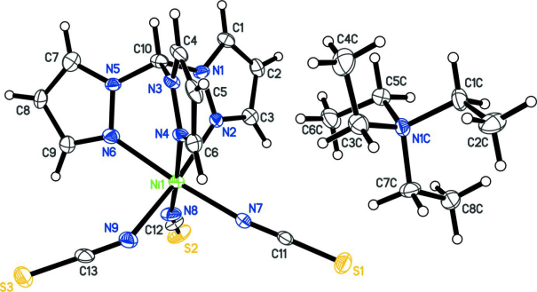

Tetraethylammonium tris(thiocyanato-κN)
[tris(1H-pyrazol-1-yl κN²)methane]nickelate(II)

4. PRESENT STATUS OF PROJECT:

Partially completed (in true sense, I don’t think any research can be ever completed!)

5. STATEMENT OF PURPOSES AND AMOUNTS OF AWARD EXPENDITURES: ( Follow format of budget in original application and list actual expenditures. )

Fellowship for Research ($4,000)

