Ready Player One

Time required: 2-3 class periods
Suggested Grade Level: 6-12

Arkansas Standards of Learning – Social Studies
EDM.1.E.1: Evaluate the roles of scarcity, incentives, trade-offs, and opportunity cost in decision making (e.g. PACED decision making model, cost/benefit analysis)
EM.2.E.1: Identify various allocation methods used in different circumstances, countries, and economies (e.g. price, auction, lottery, fiat)
PFM.8.E.1: Analyze the impact of education, training, and other factors on productivity and income potential (e.g. interpersonal skills, workforce readiness skills, ethics)

Common Core State Standards – Reading, Literature, and Writing
CCSS.ELA – Literacy.RL.9-10.3: Analyze how complex characters (e.g., those with multiple or conflicting motivations) develop over the course of a text, interact with other characters, and advance the plot or develop the theme.
CCSS.ELA – Literacy.RL.9-10.7: Analyze the representation of a subject or a key scene in two different artistic mediums, including what is emphasized or absent in each treatment.
CCSS.ELA – Literacy.CCRA.SL.1: Prepare for and participate effectively in a range of conversations and collaborations with diverse partners, building on others' ideas and expressing their own clearly and persuasively.
CCSS.ELA – Literacy.CCRA.SL.5: Make strategic use of digital media and visual displays of data to express information and enhance understanding of presentations.
CCSS.ELA – Literacy.W.9-10.3: Write narratives to develop real or imagined experiences or events using effective technique, well-chosen details, and well-structured event sequences.
Economic Concepts:

Allocation Method – method by which goods and services are distributed in an economy

Benefit – an advantage or profit gained from something

Capital – the stock of equipment and structures used in production

Cost – the effort, loss, or sacrifice necessary to achieve or obtain something

Cost/Benefit Analysis – Tool used to evaluate the alternatives in economic decision making

Fiat – allocation method in which an authority figure decides how resources will be allocated

Market – location where an exchange takes place

Opportunity Cost – highest value alternative that must be given up when scarce resources are used for one purpose instead of another

Scarcity – result of an inability to satisfy unlimited wants with limited resources

Trade-Off- a choice that involves giving up one thing to have more of another

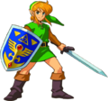
Activity #1: Allocation Methods
There are many ways in which resources can be allocated. These allocation methods include:
- First Come, First Served
- Lottery
- Contest
- Auction
- Personal Characteristic
- Authority/Fiat
- Voting/Majority Rules
- Price
Question: Assume you were designated as the central planner for society. Resources such as food, water, clothing, housing, and medical supplies must be allocated among the U.S. population. What allocation method would you employ for distributing these resources among the people? What are a few of the challenges you may face? Please explain your answer by referencing the text.

Activity #2: Design Your Own Avatar
Writing Assignment: Recall that people logged in to OASIS have avatar characters that represent them. Some choose to have avatars that look just like themselves while others select avatar features very different from their own. What would your avatar look like? What characteristics do they have? What skills/powers would they possess? Why? Write a brief essay explaining your selected avatar and their characteristics and powers they wield in the OASIS world.

Part b. Consider a longer project where students illustrate their avatar’s characteristics through drawing, collage, or computer generation. Students can then present their avatar to the class when time permits.
Activity 3: Cost-Benefit Analysis
In Ready Player One, Wade Watts views the widespread invitation by James Halliday to adventurers worldwide to join in the hunt for his fabled “Easter Egg.” Wade must decide if he should join the group of dedicated Gunters (Egg Hunters) in the hunt. Joining the search certainly has its pros and cons, but so does staying out of the hunt and hopefully remaining alive. Help Wade decide by filling in this chart with some of the advantages and disadvantages of his two possible choices.

 | Option 1  Hunt for Egg | Option 2  Don’t Hunt for Egg
Benefits  Advantages or Good Points | +  +  +  +  +  + | +  +  +  +  +  +
Costs  Disadvantages or Bad Points | -  -  -  -  -  - | -  -  -  -  -  -

Writing Assignment: Explain your decision in your own words using examples from the chart above.

Activity 4: Capital Accumulation
Wade improves his abilities in OASIS by acquiring new capital. What are some examples of new capital resources that help Wade improve his productivity? How do they help Wade be a more productive Gunter?

CAPITAL IMPROVE PRODUCTIVITY
_______________________________ __________________________________________
_______________________________ __________________________________________
_______________________________ __________________________________________
_______________________________ __________________________________________
_______________________________ __________________________________________
_______________________________ __________________________________________
_______________________________ __________________________________________
_______________________________ __________________________________________

Part b. What capital resources have you acquired over the past few years, and how have they helped you become more productive?

CAPITAL IMPROVE PRODUCTIVITY
_______________________________ __________________________________________
_______________________________ __________________________________________
_______________________________ __________________________________________
_______________________________ __________________________________________
_______________________________ __________________________________________
_______________________________ __________________________________________
_______________________________ __________________________________________
_______________________________ __________________________________________
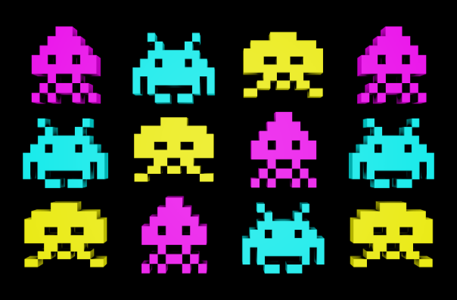
Activity #5: Fill in the blanks to see the hidden vintage arcade game
Allocation Method Fiat
Benefit Market
Capital Opportunity cost
Cost Scarcity
Cost/Benefit Analysis Trade-Offs
Instructions: Fill in the following blanks using the terms provided above to unlock the name of one of Halliday’s favorite vintage arcade games.
Sample: Money put away for a rainy day is called __ __ __ __ __ __ __. Savings
8
- When making choices, we face __ __ __ __ __ - __ __ __ __ due to scarcity.
12 1
- __ __ __ __ is an amount that has to be paid or spent to buy something.
13
- The __ __ __ __ __ __ __ __ __ __ __ __ __ __ __ __ is a method by which goods are distributed.
9 10
- An advantage or profit gained from something is known as a __ __ __ __ __ __ __.
11

- If Wade decides to play Frogger rather than Donkey Kong, then Donkey Kong represents his __ __ __ __ __ __ __ __ __ __ __ __ __ __ __.
2

- The allocation method in which an authority figure decides how resources will be distributed is called __ __ __ __.
3

- __ __ __ __ __ __ __ includes equipment and structures used in the production of a good.
4

- Cost/benefit __ __ __ __ __ __ __ __ is used to evaluate alternatives in economic decision making.
7

- A __ __ __ __ __ __ is the location where an exchange takes place.
5

- The inability to satisfy unlimited wants with limited resources is defined as __ __ __ __ __ __ __ __.
6
VINTAGE ARCADE GAME: __ __ __ __ __ __ __ __ __ __ __ __ __
1 2 3 4 5 6 7 8 9 10 11 12 13
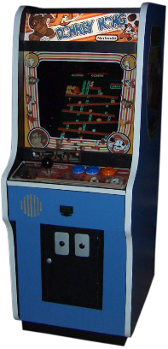
Activity 6: Currency Conversions in Arcade World
Example: We know there are 12 inches in 1 foot, thus 1 foot=12 inches. Suppose we need to know how many inches are in 3 feet. How would we do this?

3 feet * 12 inches = 3 feet * 12 inches = 36 inches
1 foot 1 foot

Now, let’s consider the OASIS world of galactic adventure and never-ending arcade fun.

Assume: $1=4 tokens
10 tokens = 1 credit
2 credits = 1 BONUS

- Suppose the Ultimate Arcade Challenge costs $5.00. How many tokens does that cost?

- With 80 tokens, how many credits can Parzival obtain?

- Assume Art3mis has 28 tokens. How many BONUSES can she get?

- Suppose Aech has 12 BONUS points. How much money has he spent to get to this point?

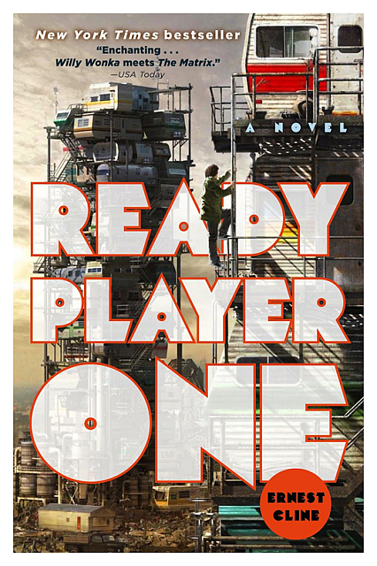
Activity #7: Media Platforms
Watch Ready Player One on video. Does the video portrayal of Wade differ from the one illustrated in the book? Please explain in your own words.

