Blackboard Instructor Reference Guide: How to Add an SafeAssignment

Southern Arkansas University, Magnolia

- Login to your Blackboard course. Click on Control Panel

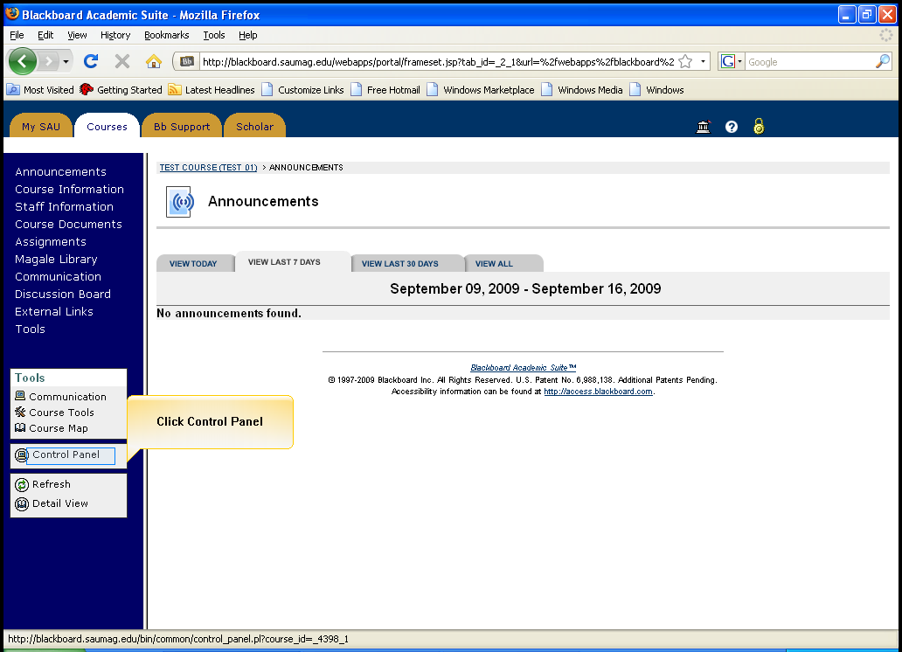
Click on Control Panel

- Click Assignments in the Content Area section

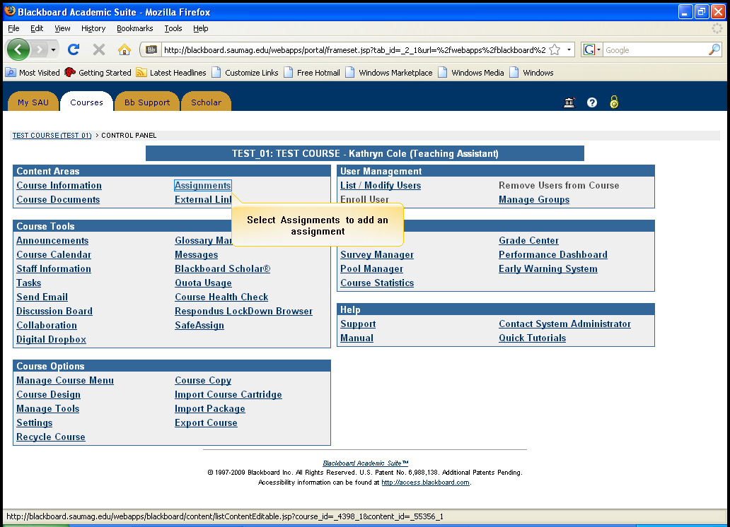
Click Assignments in the Content Area Section

- Click the Select combo box on the right side of the page

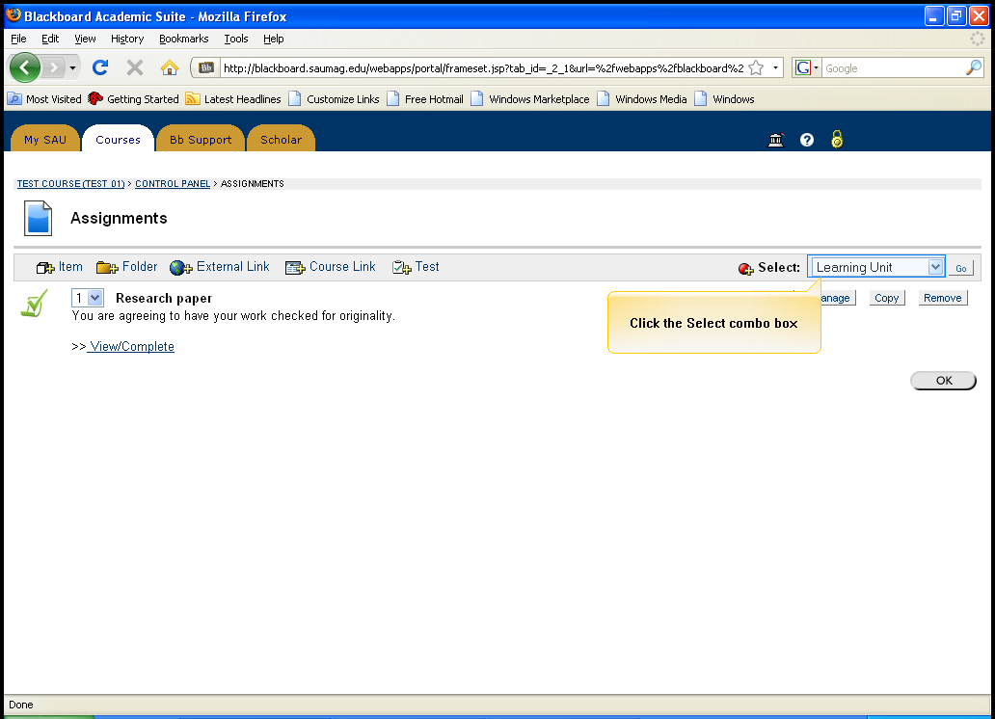
Click on Select combo box

- Select SafeAssignment from the drop down menu

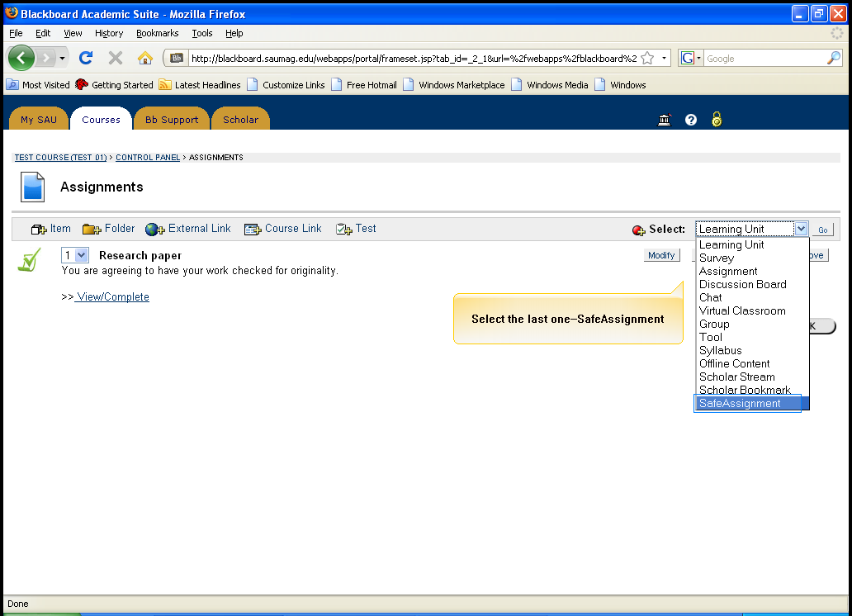
Select SafeAssignment

- Click Go

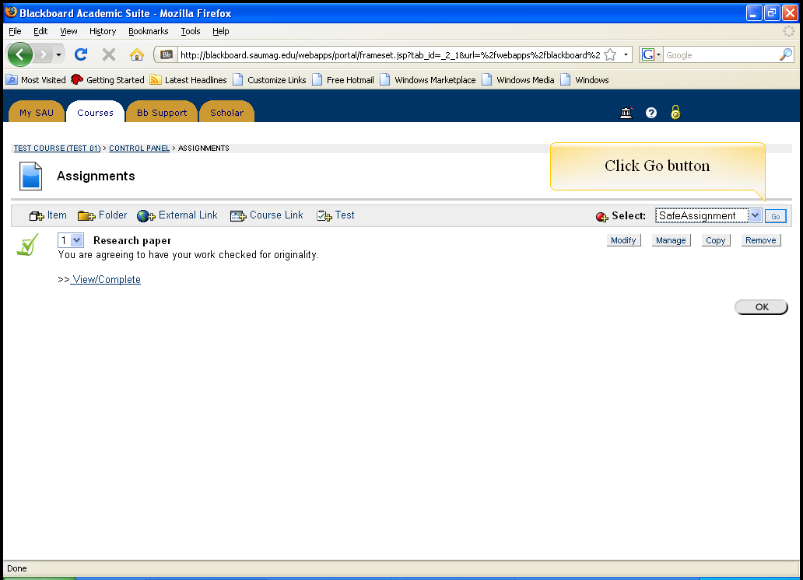
Click GO

- Enter the name of the SafeAssignment

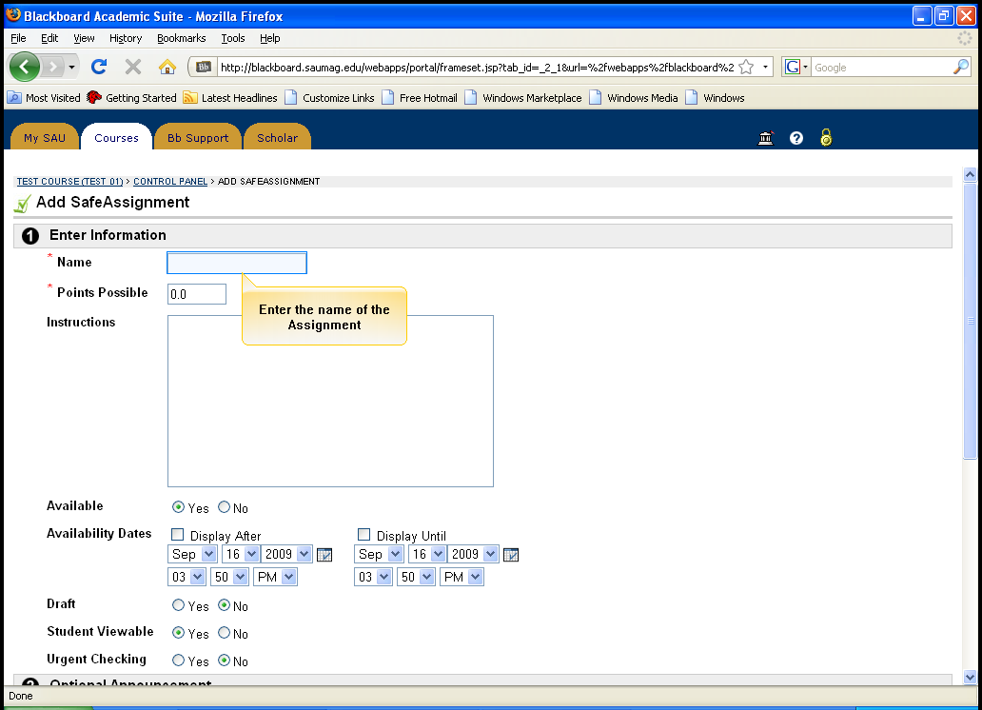
Enter the Name of the Assignment

- Enter points possible

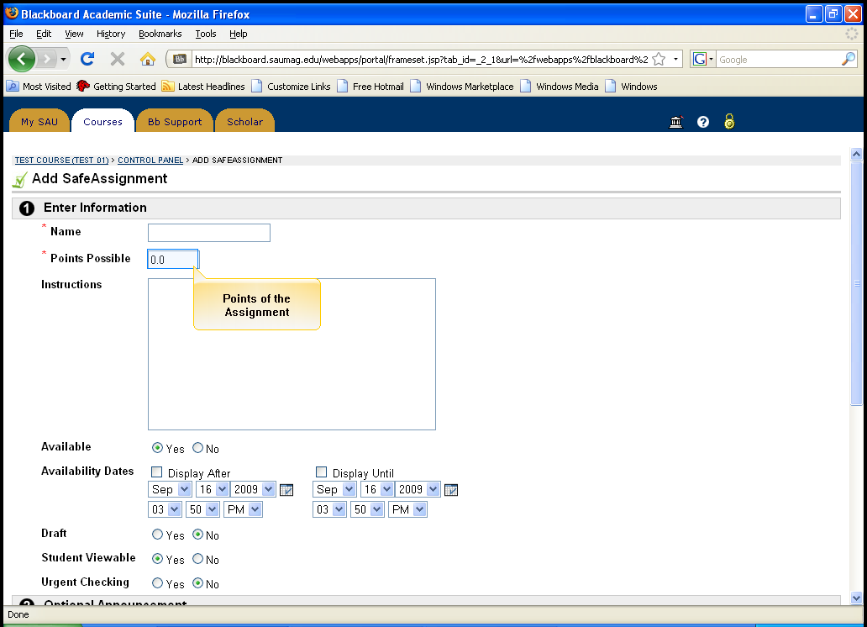
Enter Points possible

- Enter instructions for the Assignment

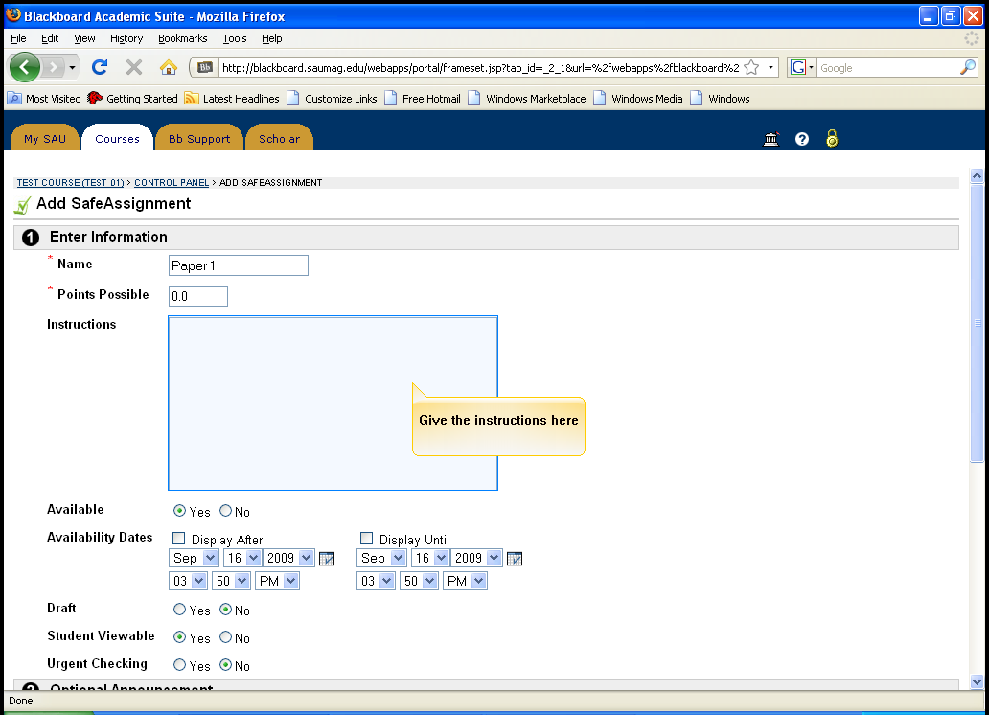
Enter Instructions for the Assignment

- Scroll to the bottom of the page, and click Submit to post the assignment

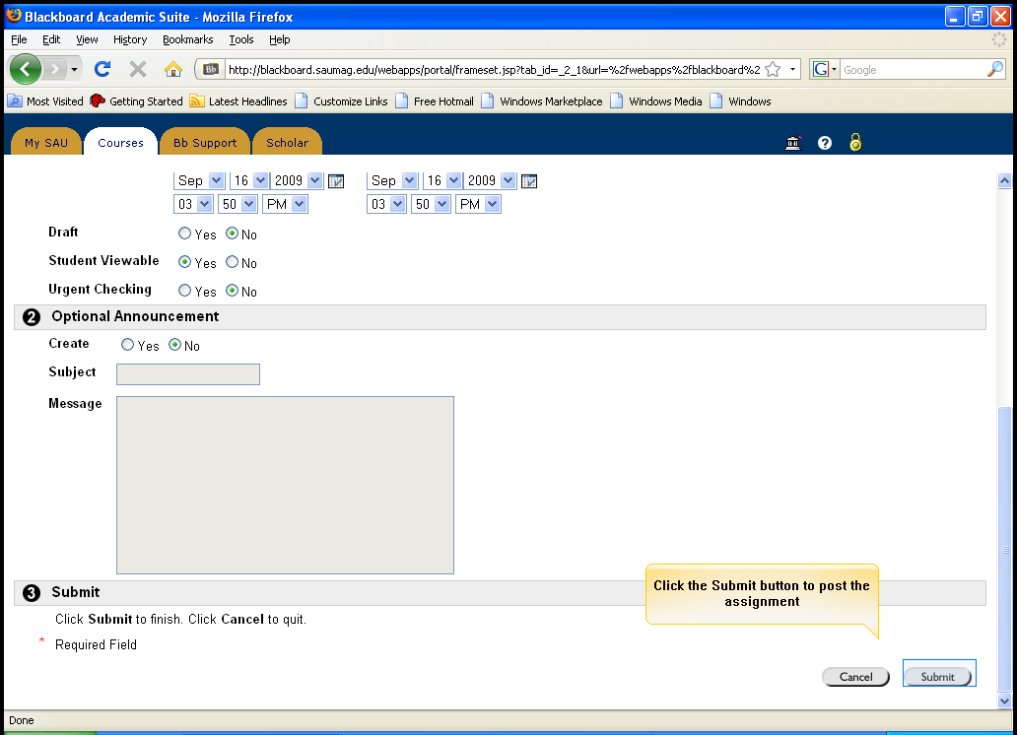
Click Submit

- Your assignment has been successfully added. Click OK.

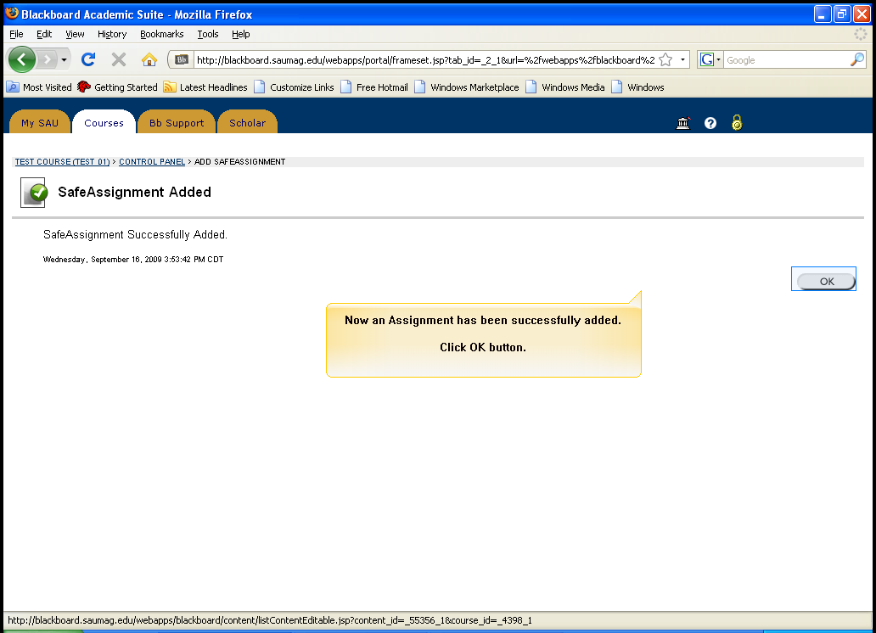
Assignment has been successfully added. Click OK

