 Blackboard Instructor Reference Guide: How to View and Download SafeAssignments

Southern Arkansas University, Magnolia

- Login to your Blackboard course. Click on Control Panel

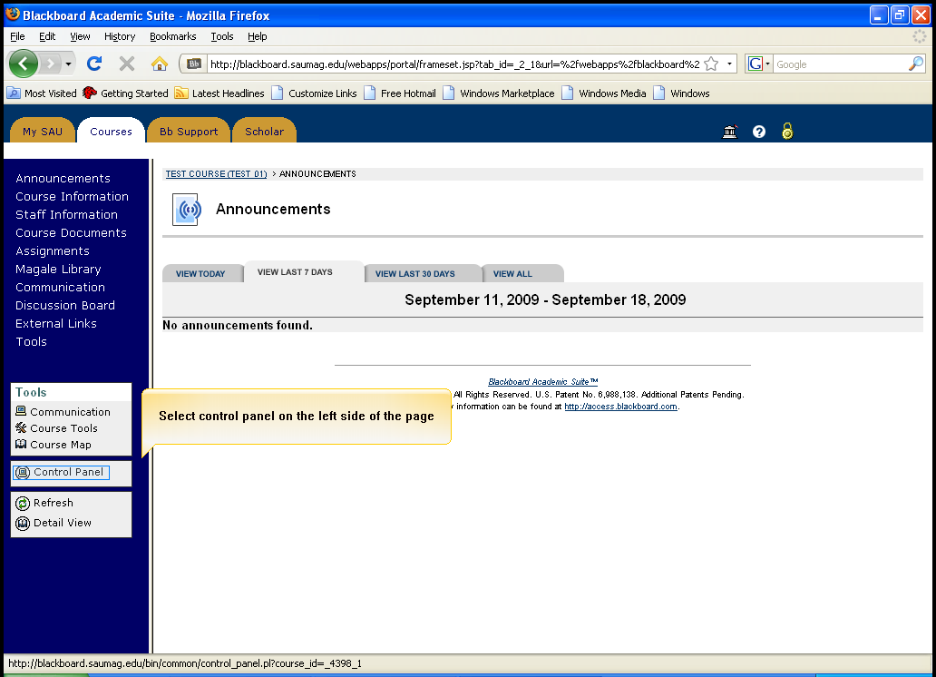
Click on Control Panel

- Select SafeAssign under Course Tools

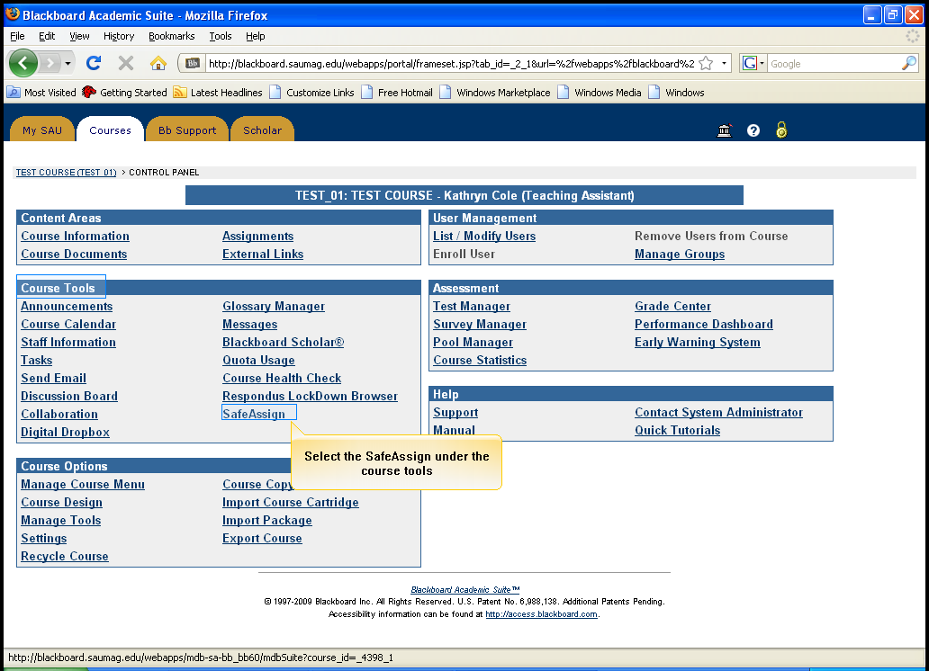
Select SafeAssign

- Click on View to view the submitted assignments

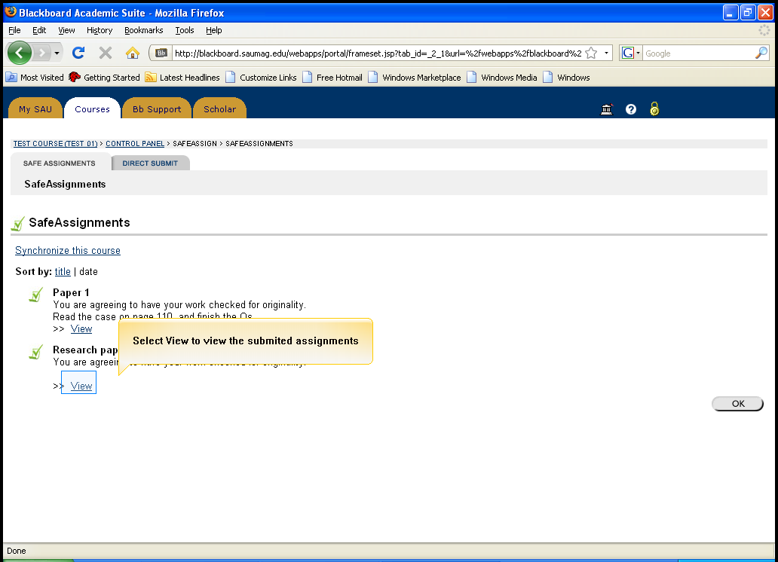
Click View

- Click the Text logo to view the paper information and paper text

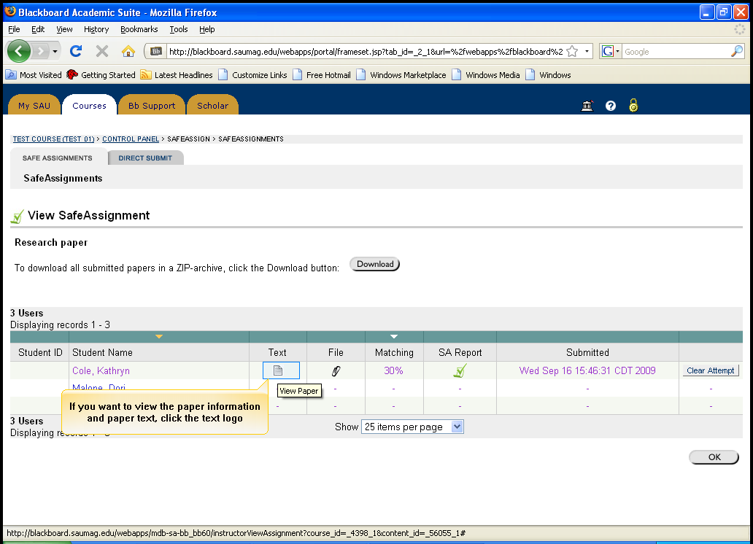
Click on the Text Logo

- When finish viewing the assignment, Close the window

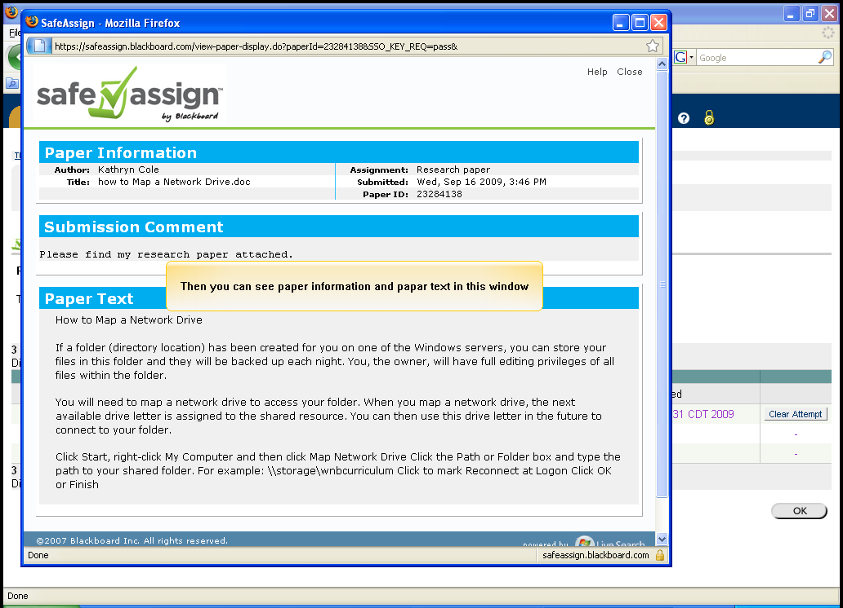
Close the window when finish viewing

- To save the assignment, click the Attachment logo

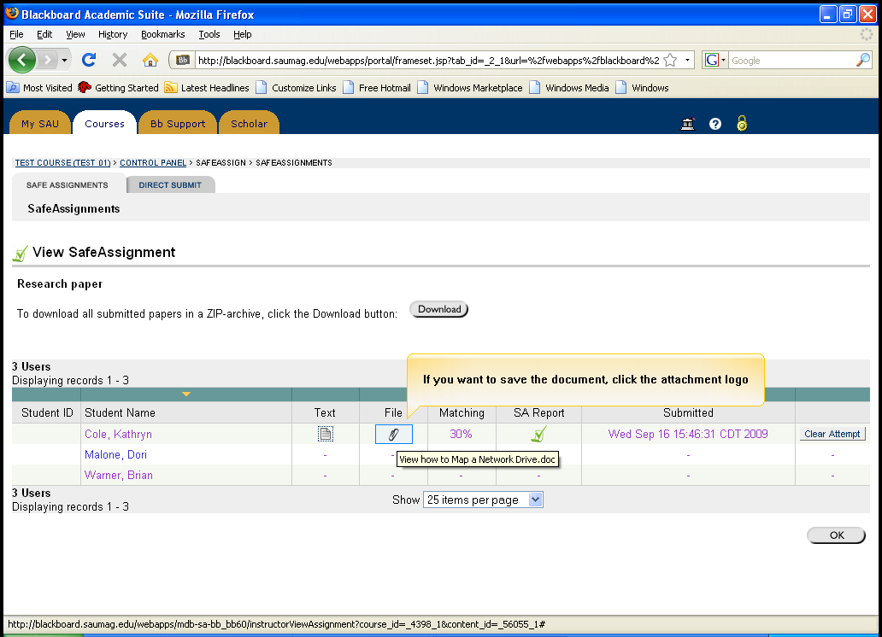
Click the Attachment Logo

- Click Save File to save it and then click OK

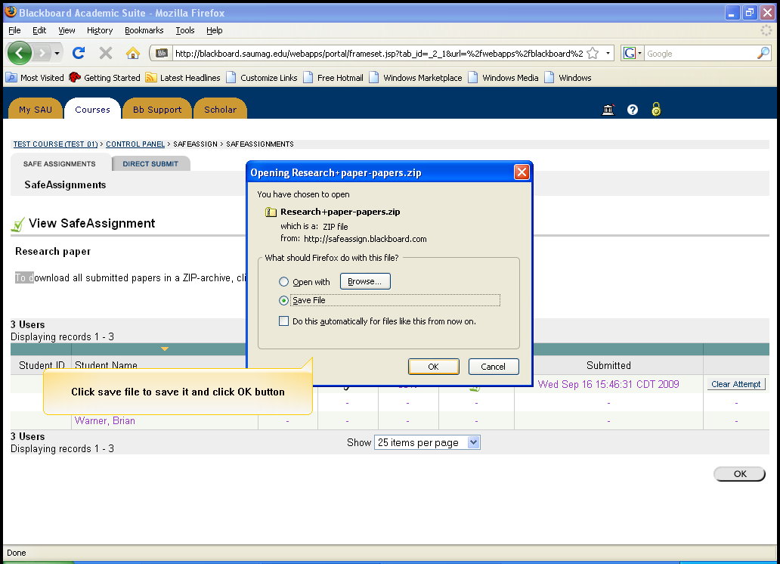
Click Save File, and then click OK

- Save to Desktop and click Save

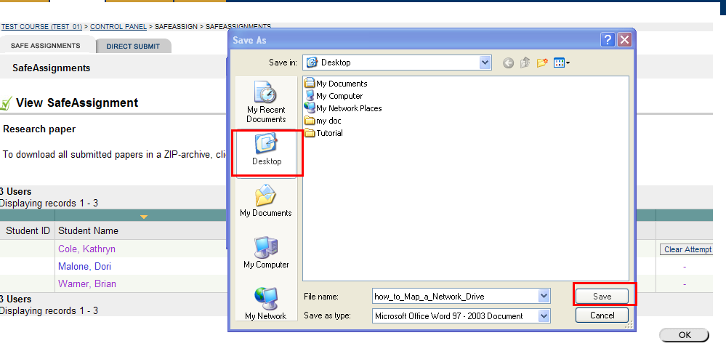
Save to Desktop and click Save

- To download all submitted assignments in a ZIP form, click Download

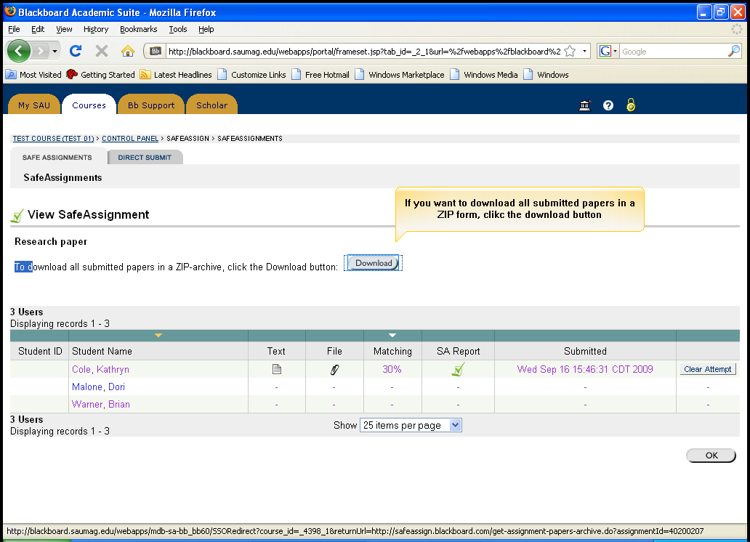
Click Download

- Click Save file to save the file, then click OK

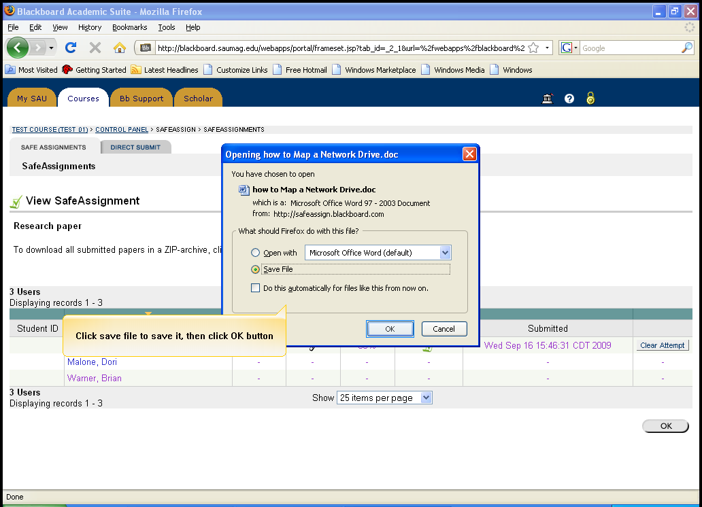
Click Save file, and then click OK

- Save to Desktop and click Save

Save to Desktop and click Save

- Click OK

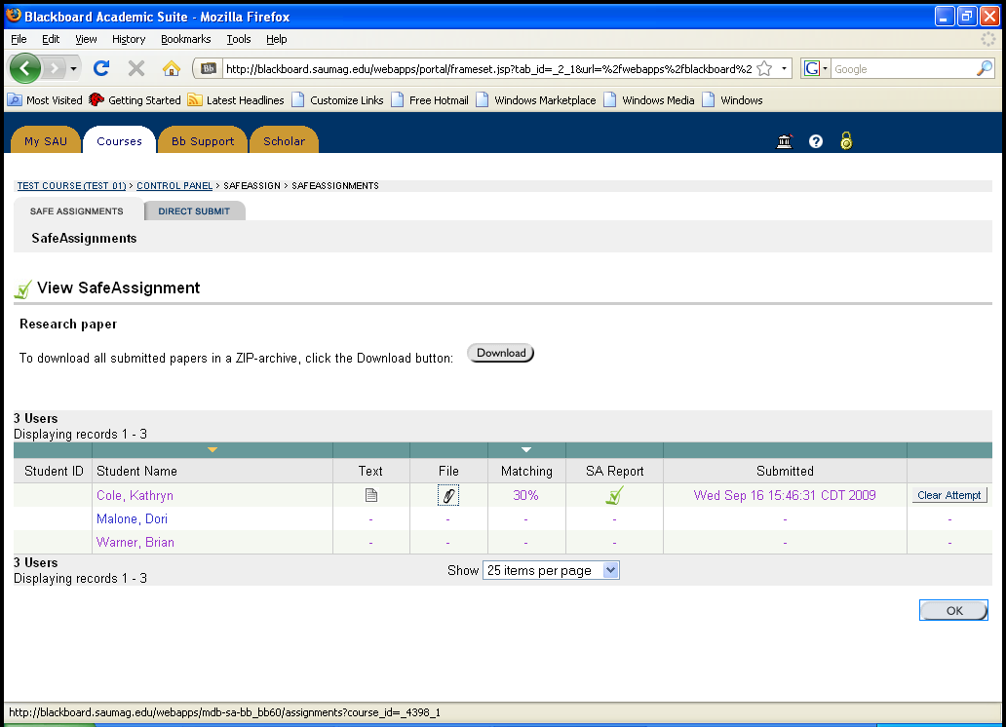

- Click OK again



