 Blackboard Student Reference Guide: How to View Grades

Southern Arkansas University, Magnolia

- Login to Blackboard and select the View Grades link under Tools

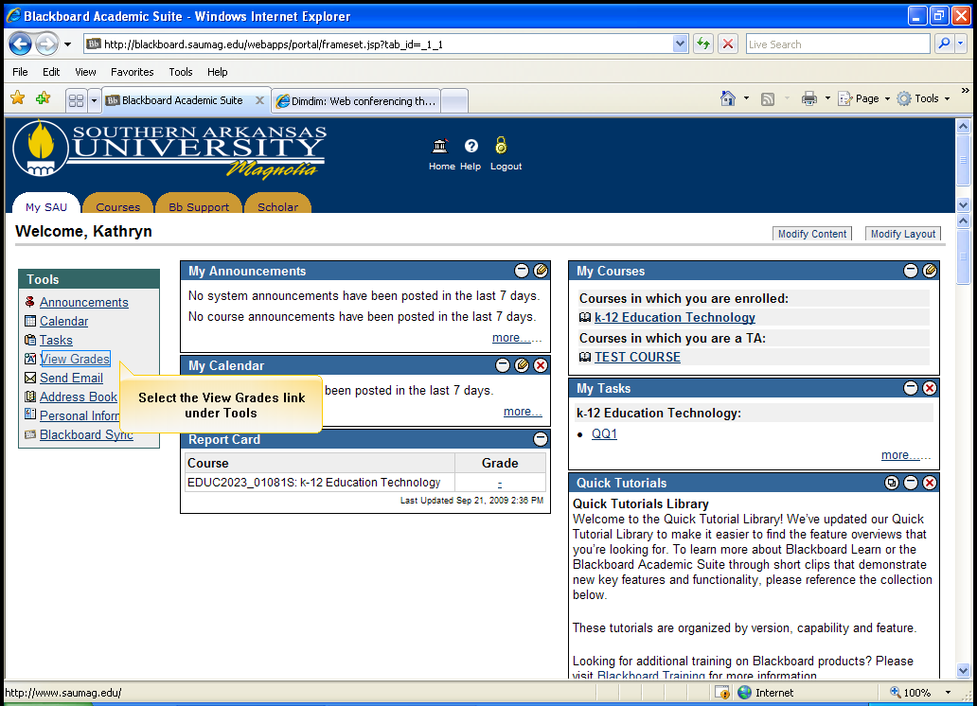
Select View Grades

- Select the Course desired

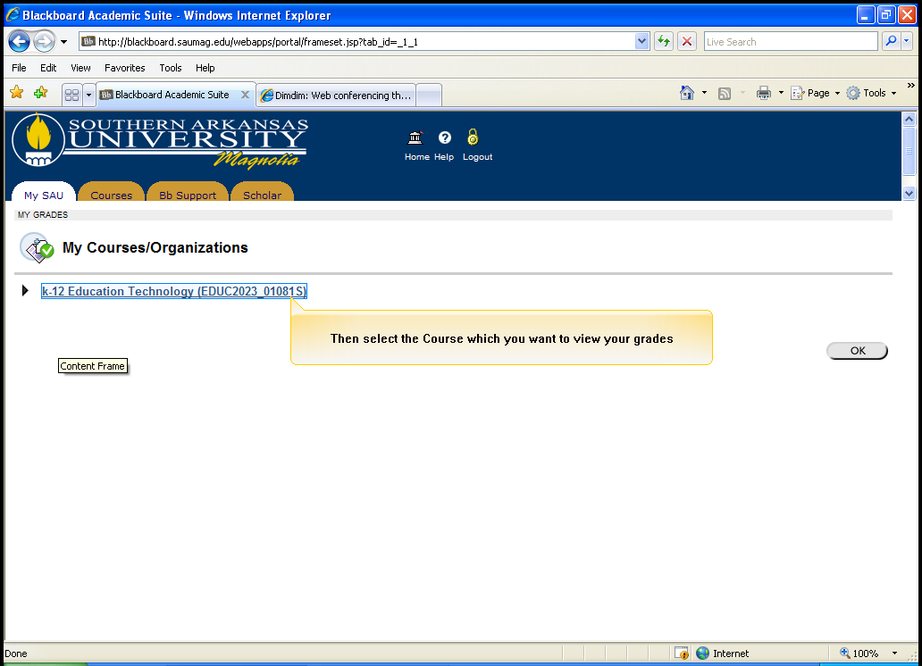
Select the Course desired

- Select Details, to view details of a specific assignment

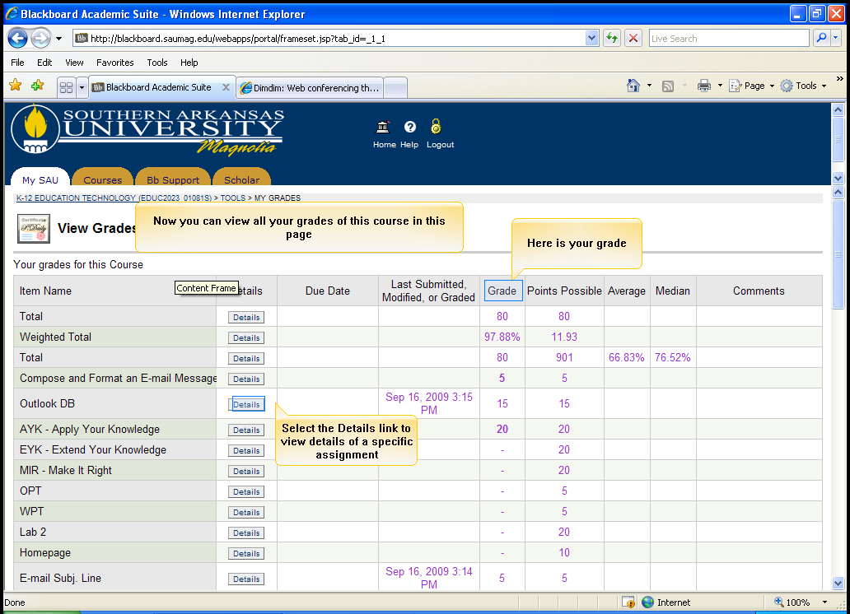
Select Details

- View the detailed information in the box

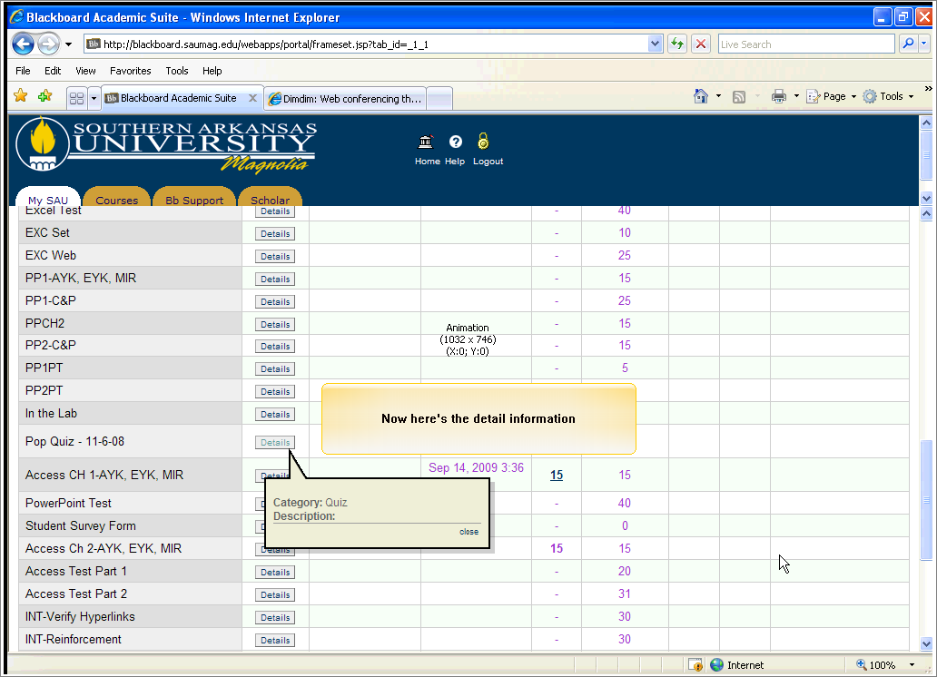
Detailed information in the box

- Scroll to the bottom of the page. Click OK

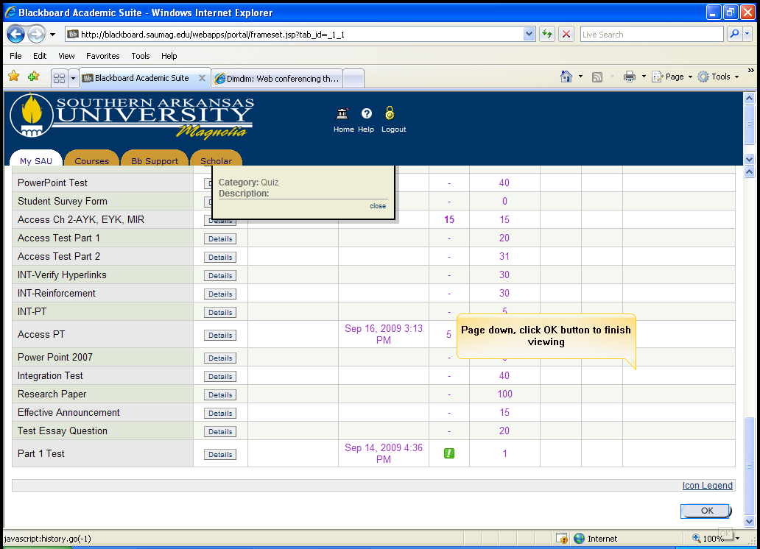
Click OK

- Click OK again to exit

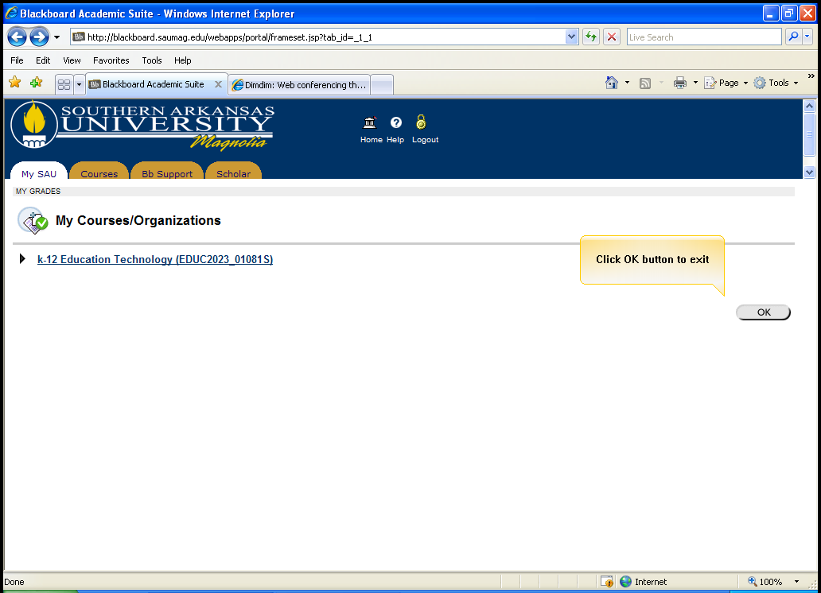
Click OK again to exit

