 Blackboard Student Reference Guide: How to Submit Assignments

Southern Arkansas University, Magnolia

- Login to your Blackboard course. Click on Assignments in the course menu on the left side of the page.

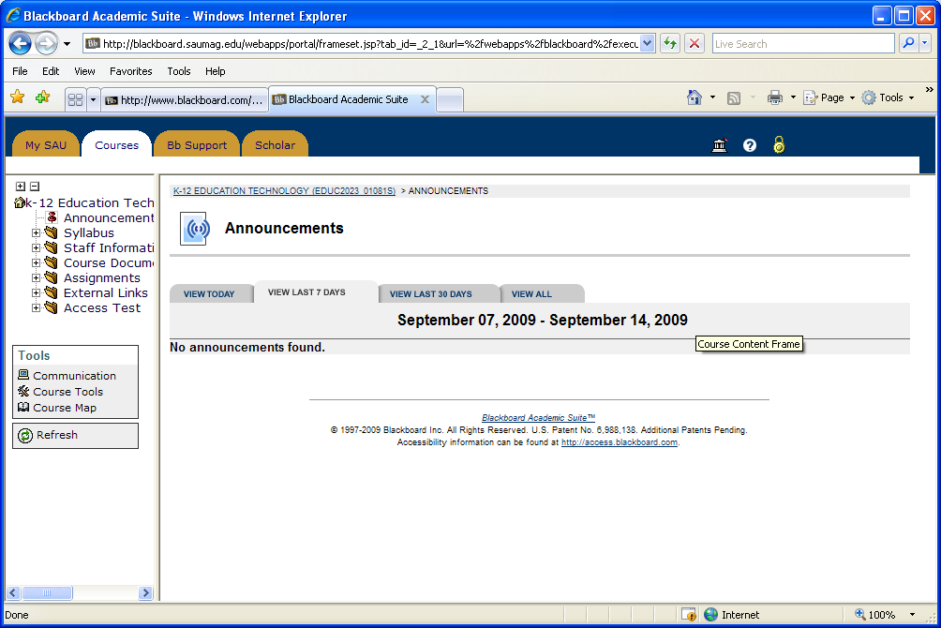
Click Assignment

- In order to submit an assignment, you will need to click the >>View/Complete Assignment link at the bottom of the Assignment.

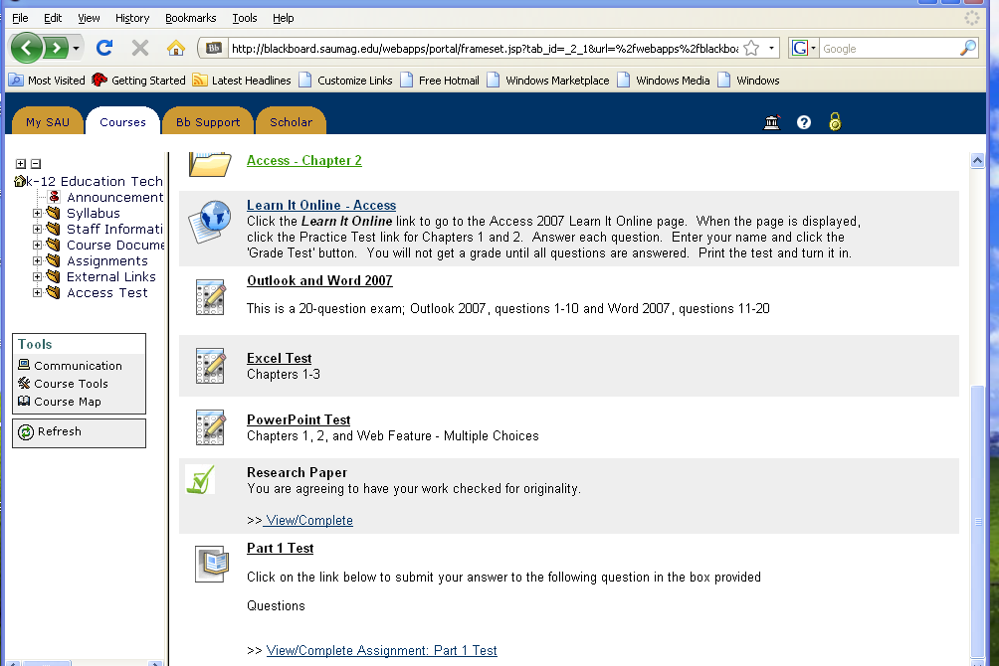
Click View/Complete Assignment

- Click the Browse button to search for your file.

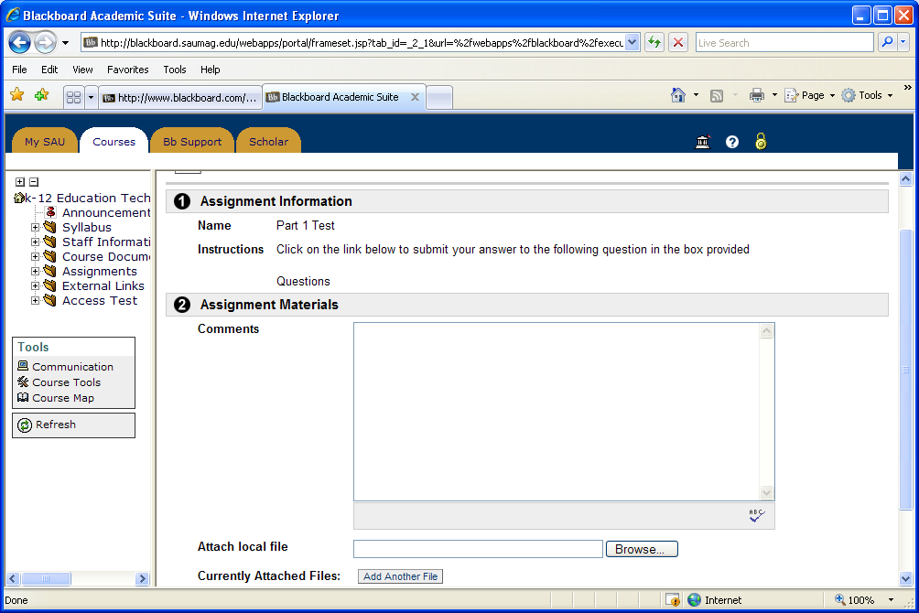
Click the Browse button

- Select the file to submit, and then click Open

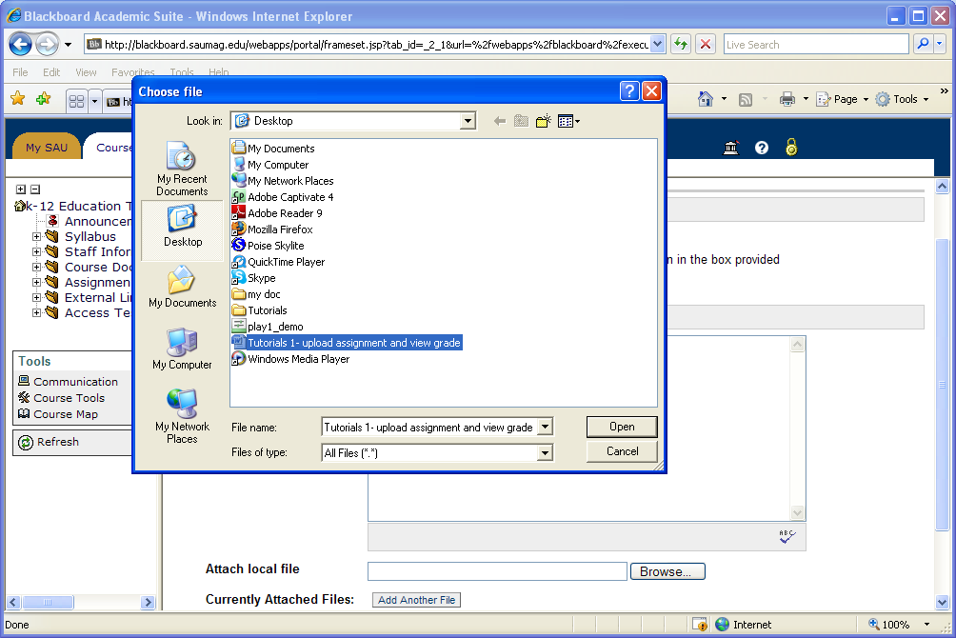
Select the file to submit

Then, click Open

- Enter your comments in the Comment text box. Click Submit

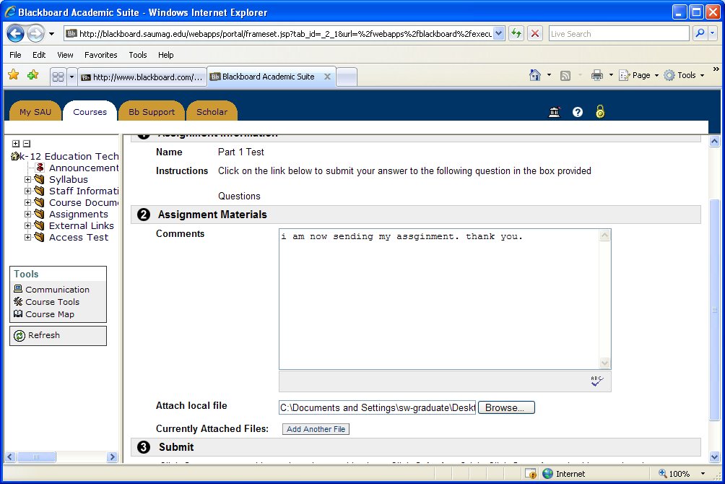
Click Submit

Enter your comments here

- Click OK.

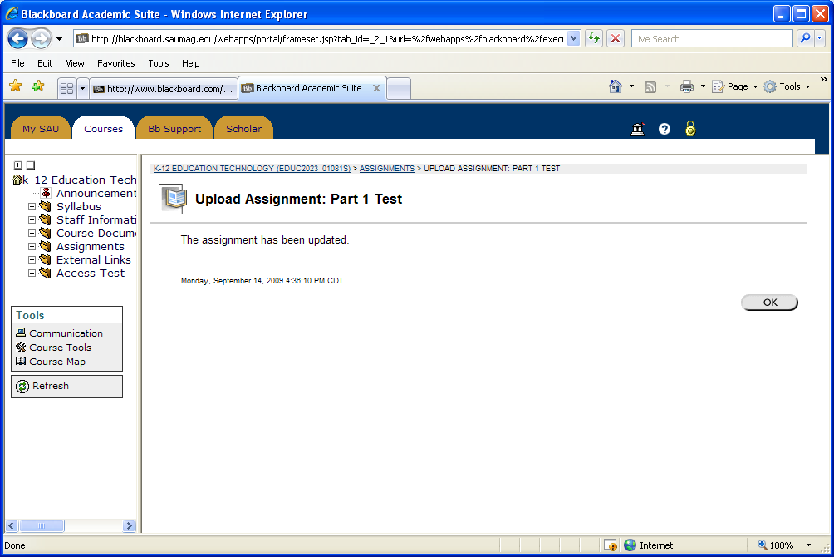
Click OK

