
Navigating Blackboard

Southern Arkansas University, Magnolia

Logging into Blackboard
USERNAME: Username (first and middle initial, last name, and four digit number, your Blackboard username can be found in Campus Connect)
PASSWORD: Last 6 digits of your SSN or student ID.

Tabs: There is a series of tabs on the top which provides access to different areas of Blackboard



Tools: On the left side of the page, the “Tools menu” provides access to different kinds of tools. Users can check announcements, calendar, and grades, send Email or edit personal information.
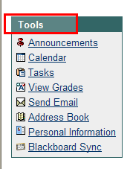

My Announcements: In the middle of the page, “My announcements” lists all the CURRENT announcements.
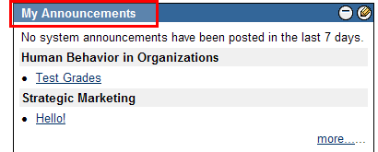
Report Card: Under “My Announcements”, “Report Card” shows updated total grades for each course
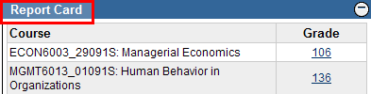
My Courses: On the right side of the page, “My Courses” lists all the courses that users are enrolled in, and users can click the underlined course title to access the course.
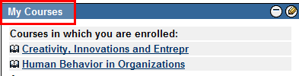
Participating in a Course
Course Menu: Located on the left side of the screen, it provides access to different sections of the course.
Navigation history: These links display the navigation history of the user.
When inside the course, users can scroll to top of screen and use navigation history to return to desired area of course. The first link in the navigational history (in this example: HUMAN BEHAVIOR IN ORGANIZATIONS (MGMT6013_01091S) ) will always link to the course entry page.
Tabs provide access to different parts of Blackboard

Logout Button
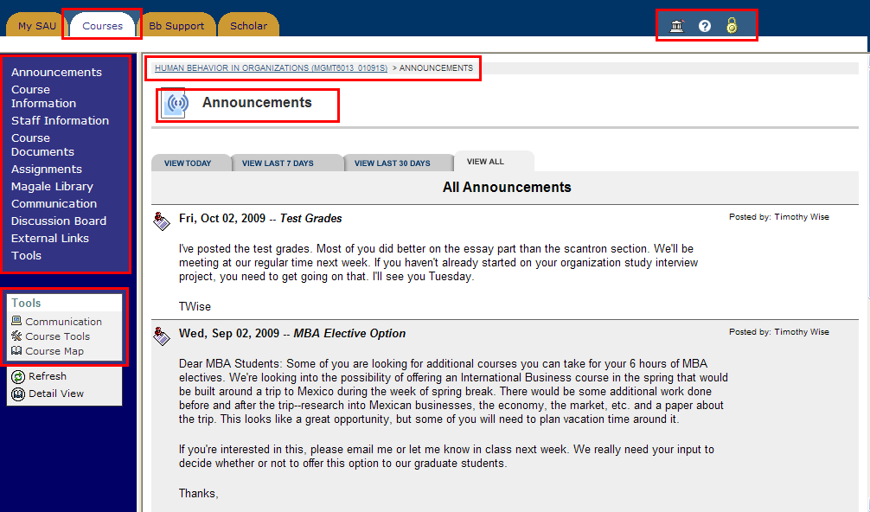
Communication link provides access to different communication tools such as Discussion Board, Messages, and Group pages.

Course Menu provides access to various sections of the course

Title of the section is displayed here

Navigation history links

Editing Your Profile
Click on the Personal Information link under the Tools menu on the left side of the page.
You can Edit Personal Information and Change Password here.
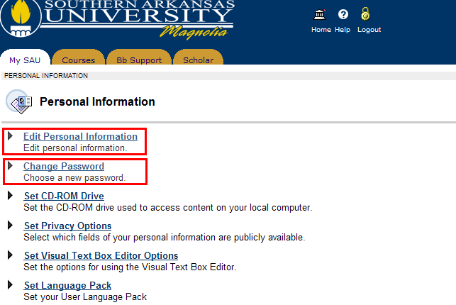
Click Edit Personal Information link to edition your personal information

Click Change Password to change your password

You are not permitted to edit personal information such as Last Name, SAU Email and username.
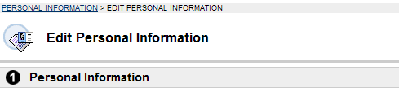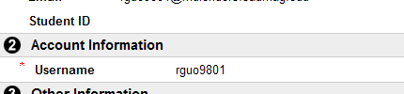
You can edit and add your personal information such as Gender, Birthday, Phone, Job Title, Address and Education level under Other Information. Click Submit at the bottom of the page to undate your personal information.
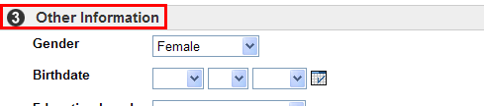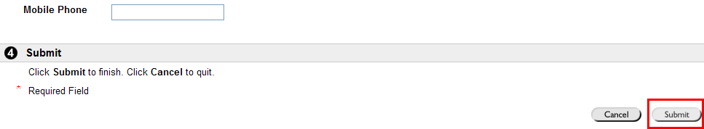
Click Submit to finish editing and update your personal information

Using the Discussion Board
Click on the Discussion Board link in the Course Menu. If you have any questions or comments, you can post them here. You can view discussions by clicking any topic in the list (In this example: Intro- Maribeth Adams ). You can create a new topic by clicking the +Thread button.
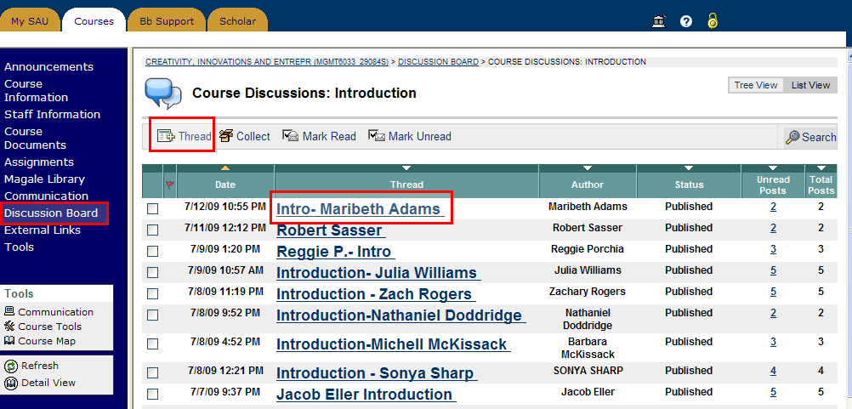
Click +Thread to create a new topic

Choose a Topic to view discussions

Discussion Board

Compose and type your subject and message.
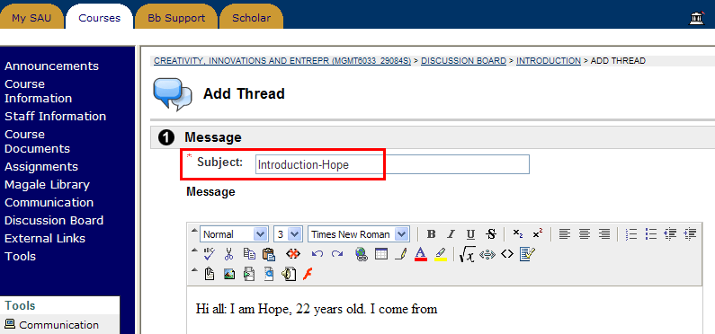
Type Subject

Enter your Questions, comments or messages here
To attach a file, click Browse to add a local file as an attachment. When finished, click Submit to post your thread.
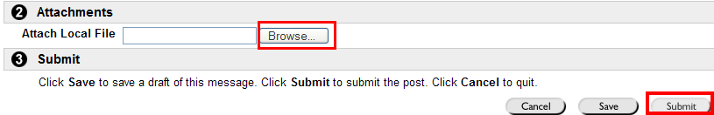

To view Thread Details, click one of the topics in the list and quote or reply to the post.
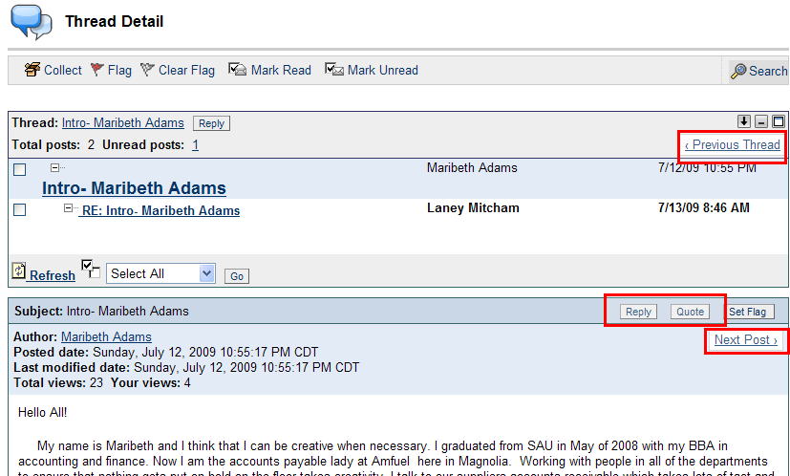
To view Next Post
Quote current post and/or reply to it.
To view Previous Thread

Submiting an Assignment
Click on Assignments in the Course Menu. To submit the assignment, click the link at the bottom of the Assignment.

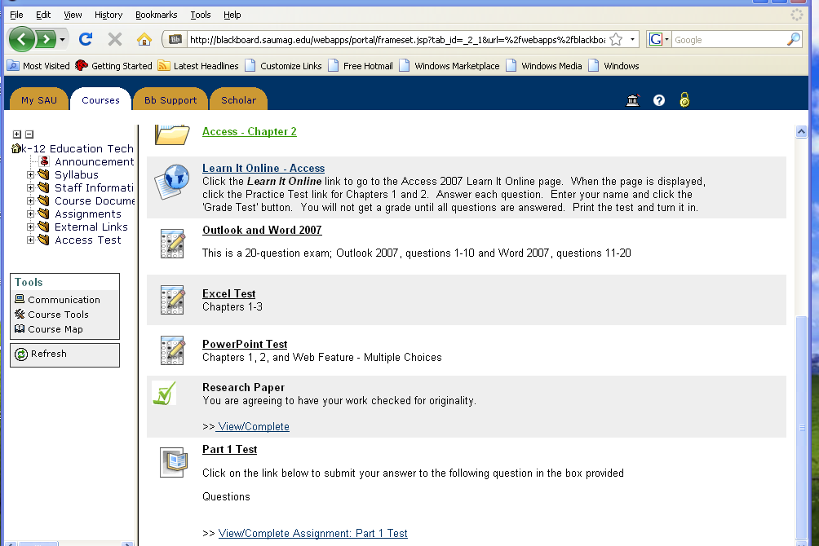
Click View/Complete Assignment link

Click Assignments

Enter any comments you wish to add in the comments box. Click the Browse button to search for the document to be attached. Click Submit.

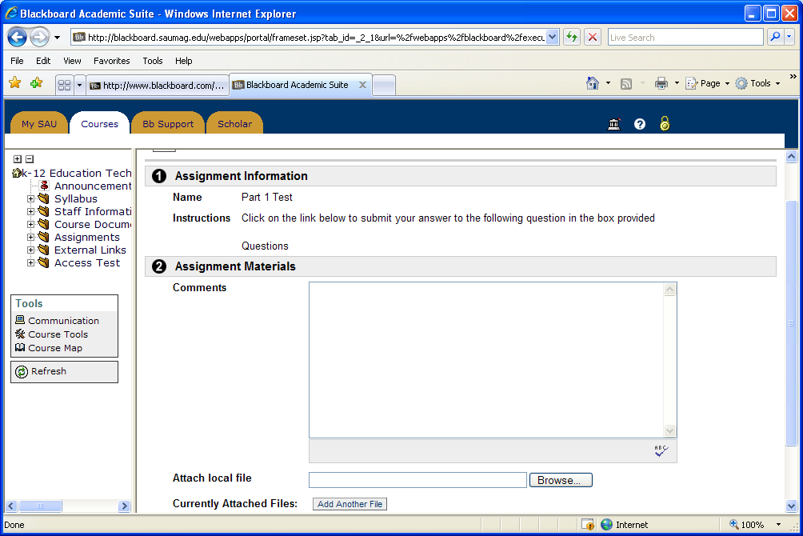
Enter your comments here

Click Submit
Click Browse

Viewing Grades
Click on the View Grades link in the Tools Box.
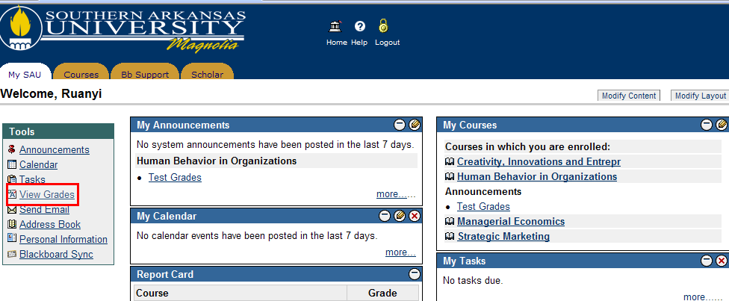
Click View Grade

To view grades, click on the course, and then click OK.
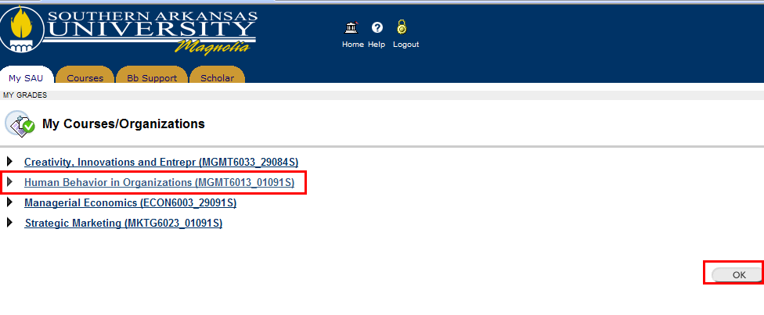
Select the Course you wish to view grades
Click OK to view grades

View the grade detail.
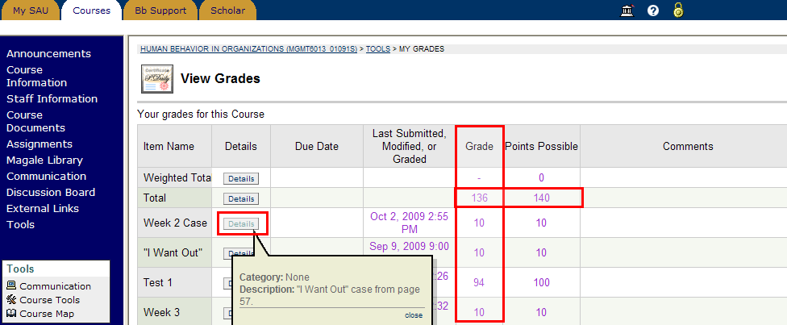
Click Detail to view detail of an assignment or exam
Your total points out of points possible

