
Blackboard Instructor Reference Guide: How to Clear Assessment Attempt

Southern Arkansas University, Magnolia

- Login to your Blackboard course. Click on Control Panel

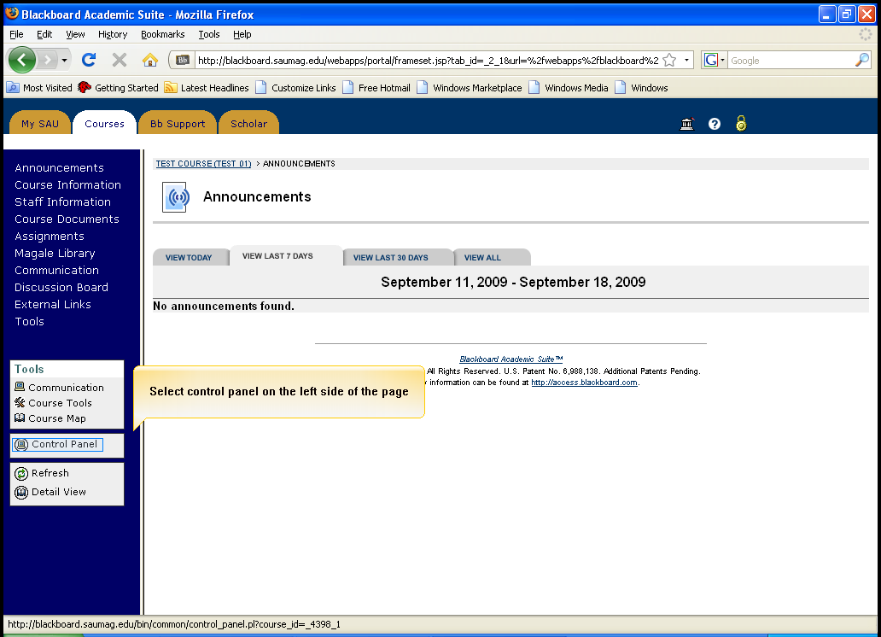
Click on Control Panel

- Click on Grade Center in the Assessment section

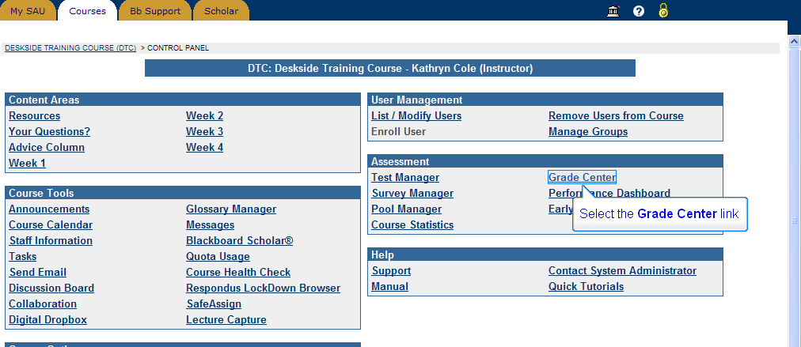
Click Grade Center in the Assessment section

- Find the cell where the student’s grade should apper on the right.

Click the Drop-down arrow icon to expose the menu option and then click Grade Details

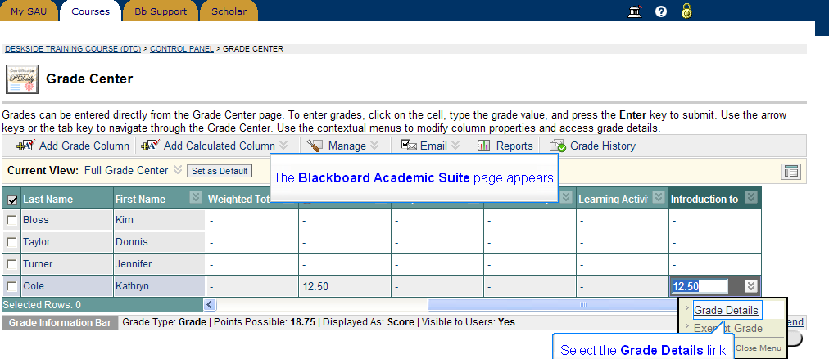
Click the Drop-down arrow icon
Find the cell where the student’s grade should appear Blackboard

Click Grade Details

- Click the Clear Attempt button, and then Click OK

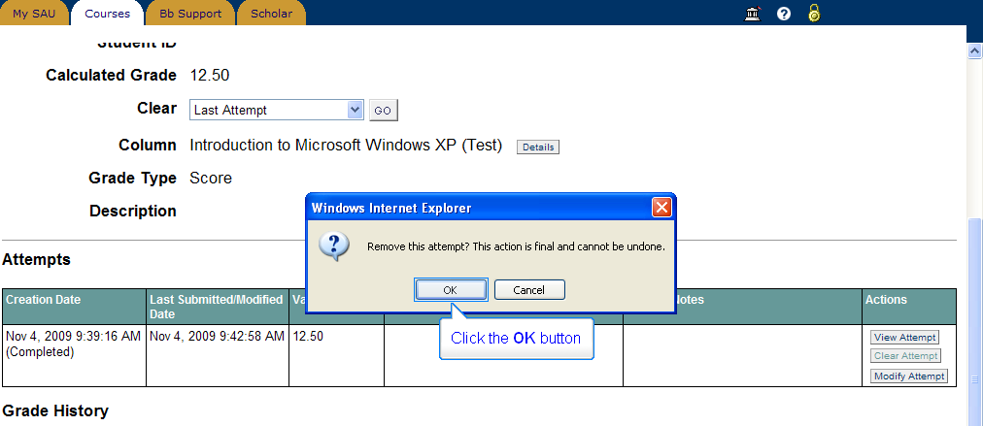
You can see student’s Current Grade here
Click OK
Click Clear Attempt

- Click OK

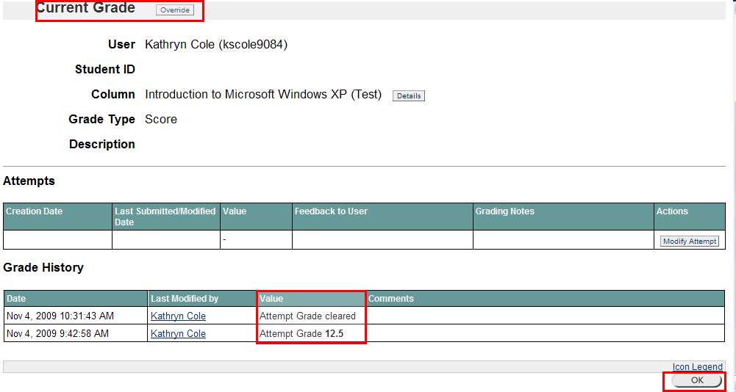
You can find ‘Attempt Grade Cleared’ under Grade History
There is no current grade here
Click OK

- Click OK again

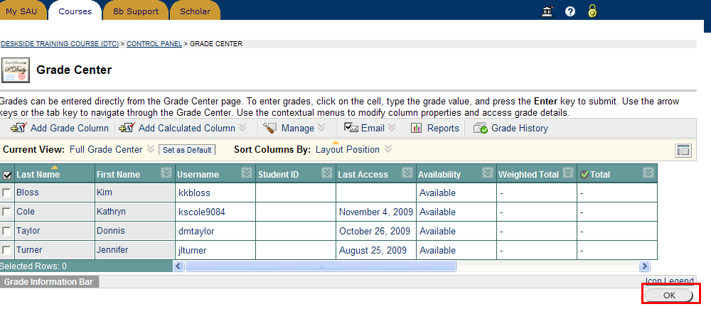
Click OK

