
Blackboard Instructor Reference Guide: How to Add Staff Information

Southern Arkansas University, Magnolia

- Access your Blackboard course and click the Control Panel link.

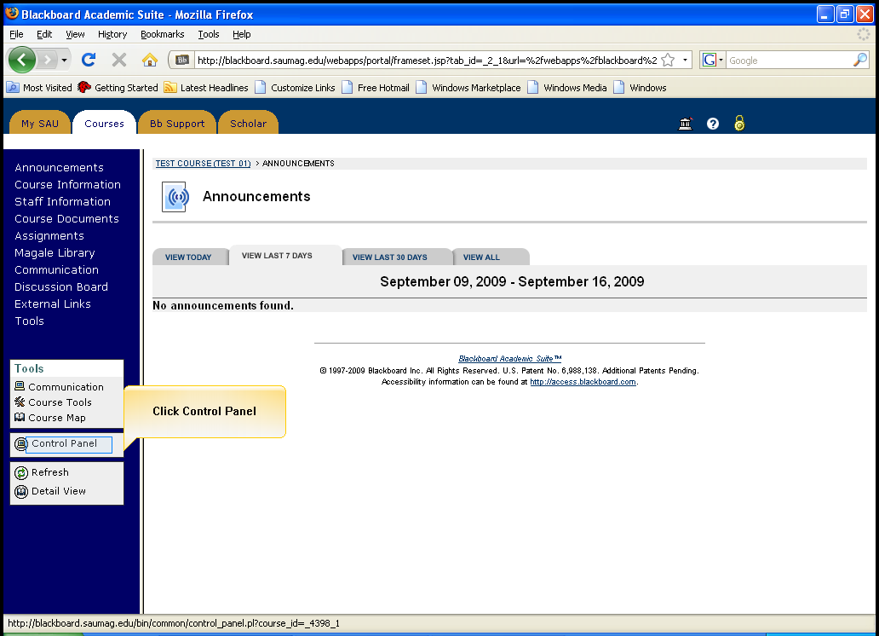
Click on Control Pannel

- Click on Staff Information in Course Tools to add or edit your personal information.
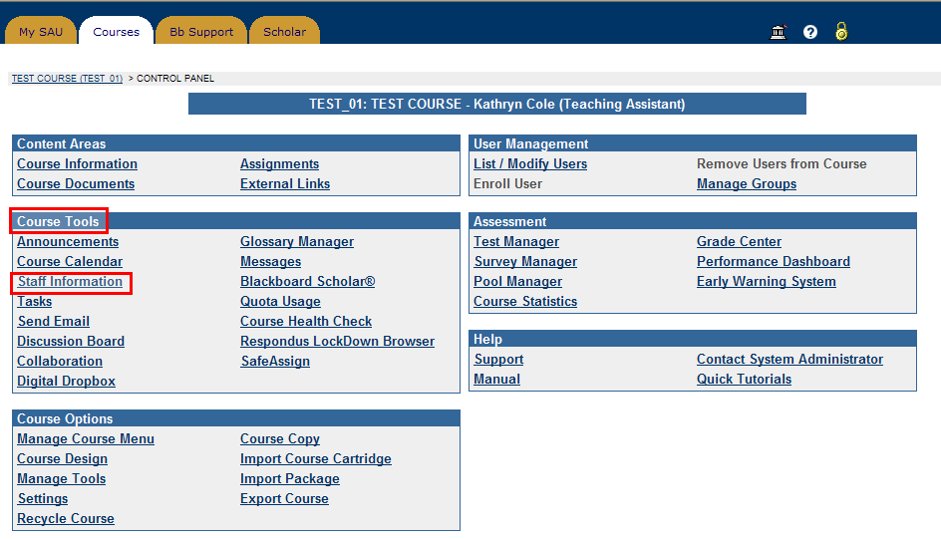
Click on Staff Information under Course Tools

- Click on +Profile to add Staff Information

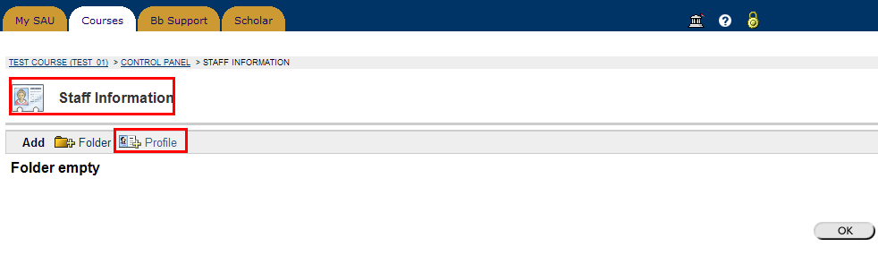
Click on +Profile to add staff information

- Add your personal information under Profile Information. Click on Browse to upload an image or photo. (Best format for uploading a picture: 150*150 JPG)
Click Submit to update the profile information.

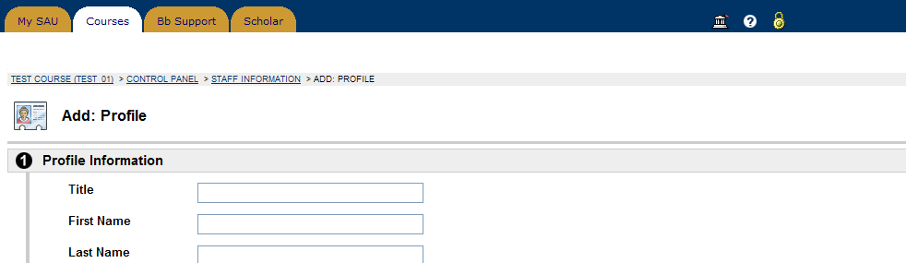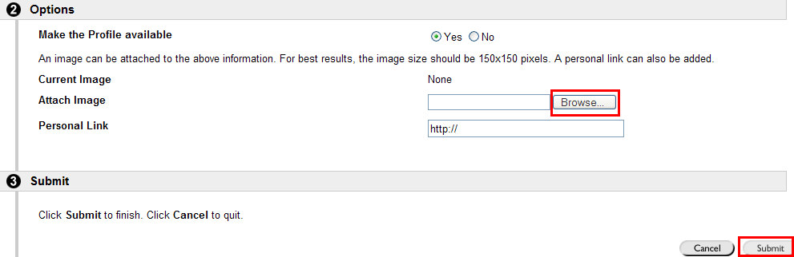
Click on Submit to update your personal information

Click on Browse to attach an image from local files.
The best format for uploading a picture: 150*150, JPG

Add the personal information here

