Blackboard Instructor Reference Guide: How to Add Graphics to Test Questions


Southern Arkansas University, Magnolia

- Login to your Blackboard course. Click on Control Panel

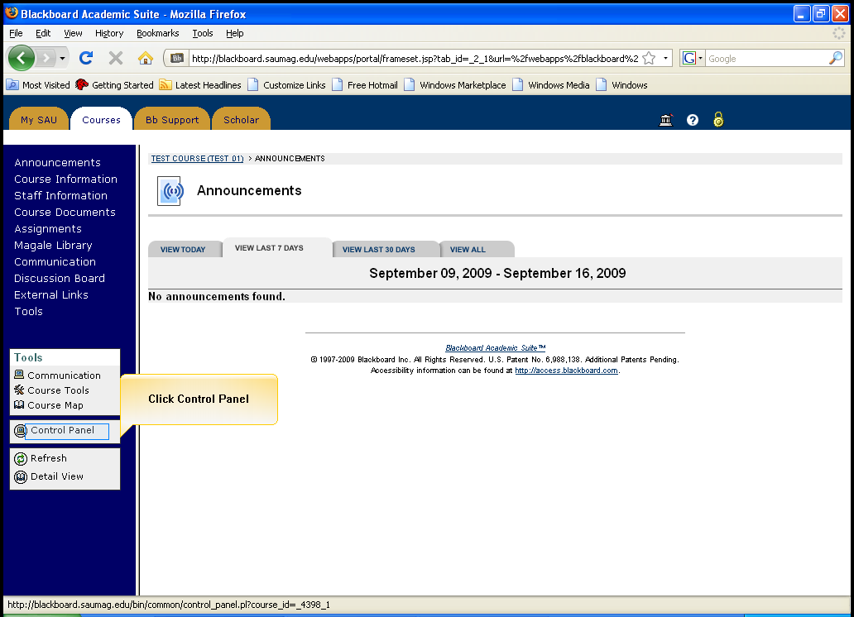
Click on Control Panel

- Click on Test Manager in Assessment

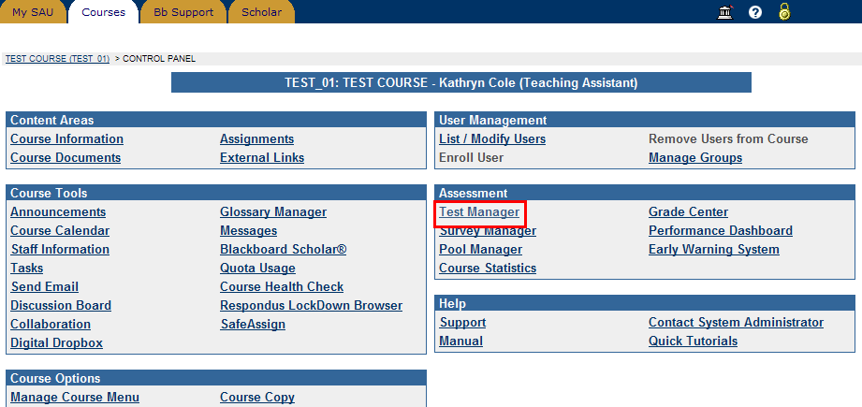
Click Test Manager

- Locate the test and click the Modify button to the right of the test.
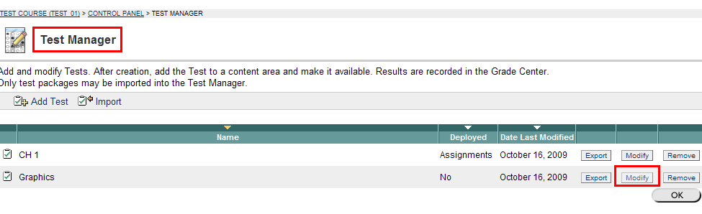
Click Modify

- Click Creation Settings

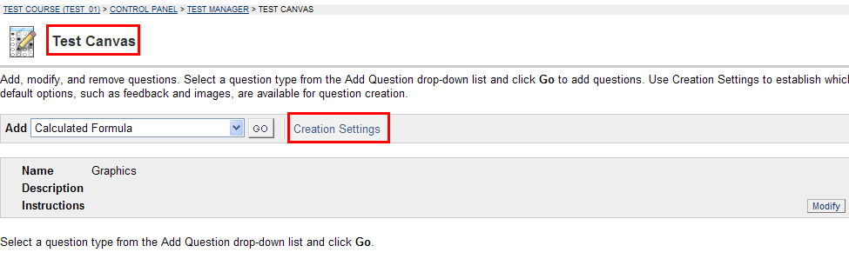
Click Creation Settings

- Click in the box to select ‘Add images, files, and external links to questions’. Click Submit at the bottom of the page.
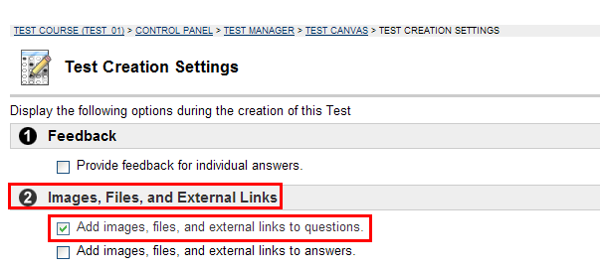
Select Add images, files, and external links to questions.

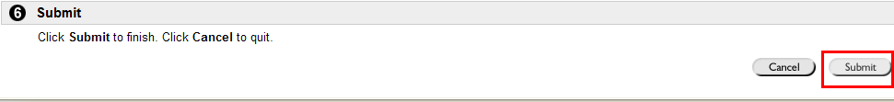
Then Click Submit

- Click OK to go back to the Test Canvas page.
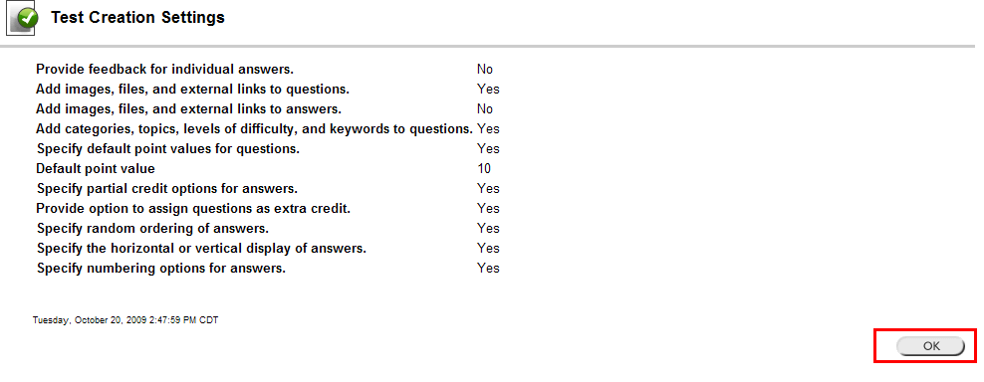
Click OK

- Select a question type from the Add Question drop-down list. Click Go.
(In this exmple, we use multiple choice.)
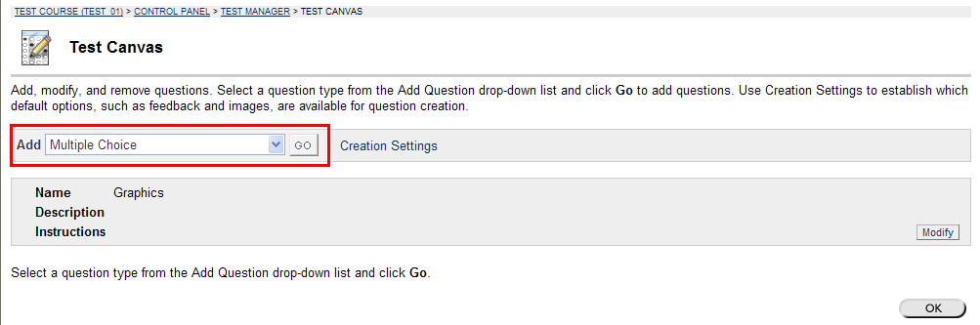

- Under Add/Multiple Choice Question page, you can add question text, give point value, and upload graphics or pictures to the question.
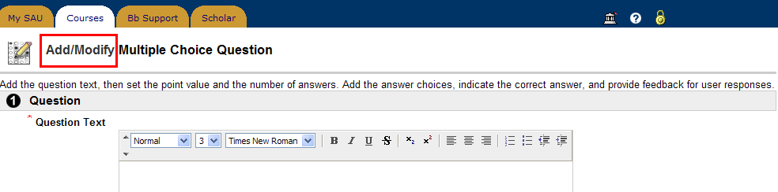

- Click Browse to search for the graphic or picture you want to use.
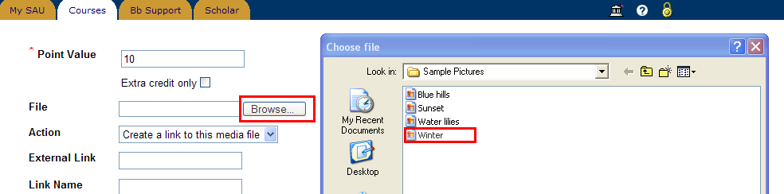

- Select ‘Display image within the page’ in the drop-down list.
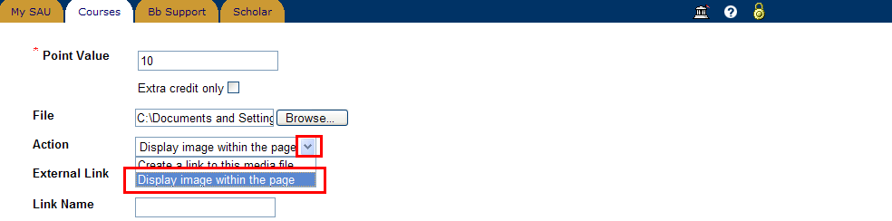

- Click Submit.

- Click OK to finish or click Modify to continue modifying the question.
