Magale Library
USER GUIDE 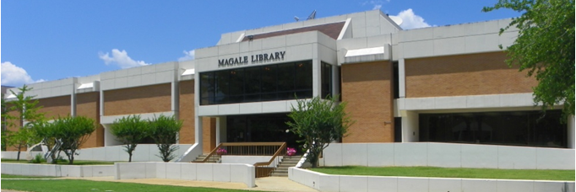
Fall 2014

Contact Information:
100 East University
Magnolia, AR 71753
Information Desk: (870) 235-4170
Fax: (870) 235-5018
Semester Hours:
Sunday | 2:00 p.m. – 11:00 p.m.
Monday-Thursday | 7:30 a.m. – 11:00 p.m.
Friday | 7:30 a.m. – 5:00 p.m.
Saturday | 10:00 a.m. – 4:00 p.m.
(Holiday-Break hours-days vary from above.)
Visit us on the Web at:
http://web.saumag.edu/library
Your access to a world of information!

Access Information

Faculty, Staff, and Student Computer Account Login
Login information is needed to access most online services including BlackBoard, student e-mail, my SAU, and the library’s electronic resources.
Usernames: Students may obtain their username by selecting mySAU (located on the SAU homepage). Once at the mySAU webage, select “New Users Click Here” and submit your request. Typically, the Username is the first and middle initial, last name, and an assigned four digit number. (i.e., iastudent4321).
Passwords: Default passwords are usually the last six digits of your social security number unless otherwise stated.
IMPORTANT: Always log out when finished!

Student E-mail Access
All SAU students are provided a free e-mail account. The e-mail account is hosted by Microsoft Live@edu
- You can find your Muleriders E-mail at http://web.saumag.edu/mail or you can go to the mySAU home page and select Student Email in the bottom-left menu.
- Your e-mail address is your current username plus @muleriders.saumag.edu. (i.e., ABStudent1234@muleriders.saumag.edu)
- Your initial password will be given in CampusConnect via mySAU located at web.saumag.edu. Typically, the password is the last six digits of your SSN OR your first, middle, & last initials in CAPS followed by the last 6 digits of your SSN and an !. (i.e., ABC456789!)
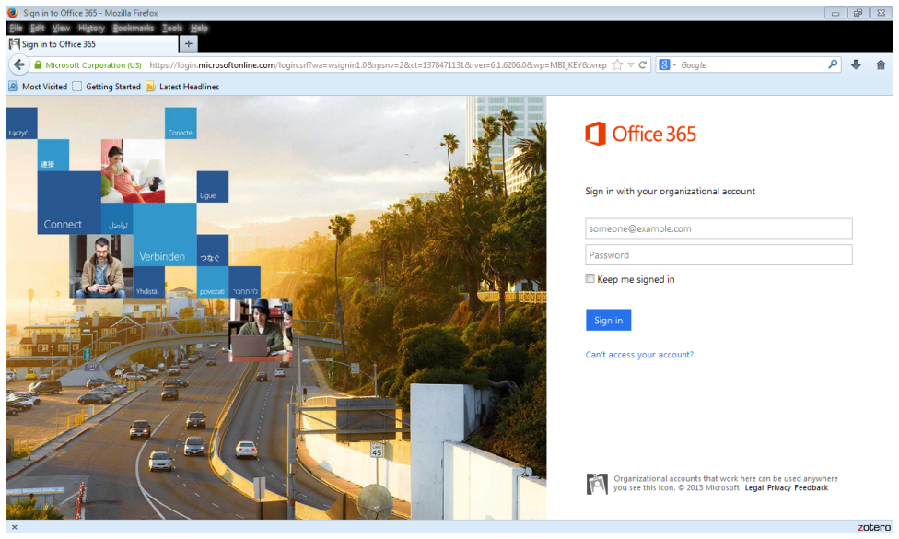

Campus Connect

To access, go to the SAU home page at web.saumag.edu Next, click on mySAU and login using SAU username and password. If you do not have a SAU username or password, please select “New Users Click Here” and submit your request. Through Campus Connect, you may:
- View current class schedule  - View grade report  - Check course availability  - View financial aid functions | - View unofficial transcripts  - View demographic information  - View holds on your account

Blackboard
Blackboard is a Web-based education tool that accompanies many SAU courses. Depending upon the instructor, Blackboard allows students to access information about their courses and perform a variety of tasks, such as submitting assignments. To access, go to the SAU homepage, select the Blackboard link. Log into Blackboard from the SAU homepage using your login ID (i.e. ABStudent1234). Your default password is the last 6 digits of your Social Security Number).

Printing Files
Your technology fee provides you an allotment of $5.00 for printing per semester (color $.10 / b&w $.02 –per page).

Additional pages can be purchased in increments of $5 at the Business Office (On average, students print apx. 71 pages per semester.) Students may call the Business Office Monday-Friday from 9 a.m. to 4 p.m. and purchase additional allotments with a debit or credit card. Unused pages that were purchased above the allotment will be rolled forward to the next semester.

Magale’s Online Resources

Available via: http://web.saumag.edu/library

Magale’s Quick Search Electronic Collections
Magale Library subscribes to a federated search service that allows students to search most of Magale’s electronic resources simultaneously. The Quick Search Electronic Collections tool is available via the Magale Library Webpage. Users often find it best to limit their search to “Full-text” items to only retrieve items they can view in their entirety via the computer. Users often also choose to limit their items to “Scholarly/Peer-reviewed Journals” to assist them in retrieving scholarly materials.

Online Databases
Magale Library subscribes to many online databases. Databases are collections of online journal, magazines, newspapers, and other publications that typically contain thousands of full-text articles and citations. Magale’s online databases are available via the library’s homepage; see “Online Resources,” then “Databases by Title.”

Online Journals
A quick way to see if the library subscribes to a specific full-text online journal is by using the A to Z list. The A to Z list is located via the library’s homepage; see “Online Resources,” then “E-Journals by Title”.
Magale’s Popular Online Collections:
- EBSCO Host  - Gale Databases  - JSTOR | - Science Direct Database  - Films on Demand  - EBSCO eBooks
Interlibrary Loan Services
Current students, faculty, and staff of Southern Arkansas University may use Interlibrary Loan Services to obtain materials from other libraries not available from Magale Library. Response times from lending libraries vary. Please allow up to two weeks for delivery of materials.

You may use the appropriate online forms available via the Magale Library website when Interlibrary Loan materials are needed. Paper forms are available in the library at the Reference Desk.

The library provides current undergraduates with 10 free requests per semester. Graduate students are provided with 20 free requests per semester. Students will be notified when their limit has been reached. Faculty members currently have no requests limit per semester.

The Interlibrary Loan Office is open Monday through Friday, 8 a.m. to 4 p.m. Requests submitted on weekends will be processed on Mondays.

For more information contact Donna McCloy, Interlibrary Loan Librarian, at 870-235-4178 or dmmccloy@saumag.edu.

Magale’s Popular Collections & Resources
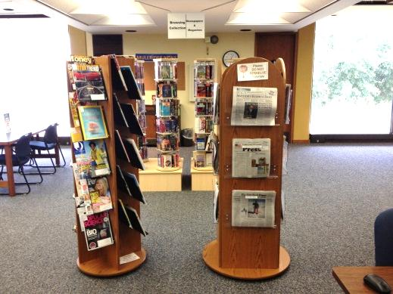 | The Magazines and Newspapers Collection is located on the north side of the second floor, opposite the library’s main entrance. Magale subscribes to many popular local, state, and nationally recognized papers and magazines.
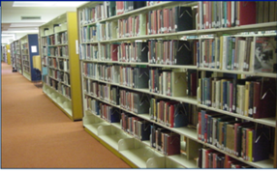 | The Main Collection is located on the third floor and contains the majority of Magale’s printed resources. These materials are arranged according to the Library of Congress classification system and contain books from each classification to support the studies at SAU.
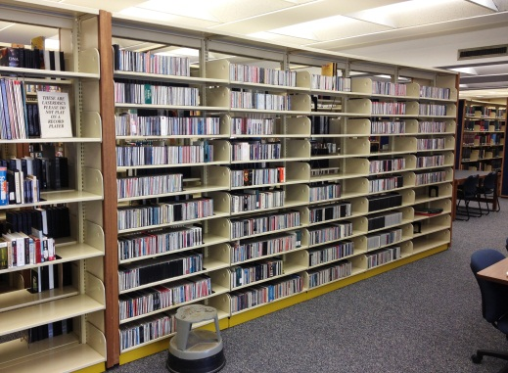 | The Music CD Collection is located at the north side of the second floor with the AV Collection. The collection contains over 1900 CDs of recordings including instrumental and vocal works from a variety of genres including popular recording artists.
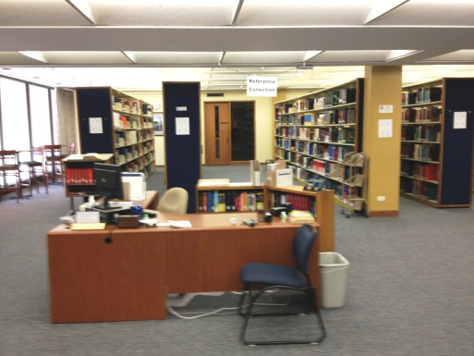  32 | The Reference Collection is located on the second floor and contains many general to subject-specific resources including dictionaries, encyclopedias, thesauruses, handbooks, guidebooks, almanacs, annuals, atlases, maps, and much more!
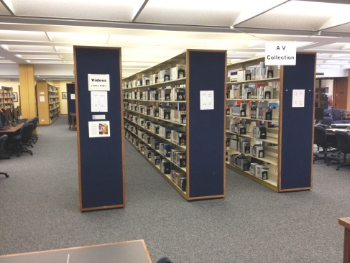 | The Audio-Visual (AV) Collection is located on the second floor and contains a variety of VHS, DVD, books on CD, CD-ROM, and LP resources in subjects and genres to support the studies at SAU. The Audio-Visual Collection uses the Library of Congress classification system and includes popular movies.
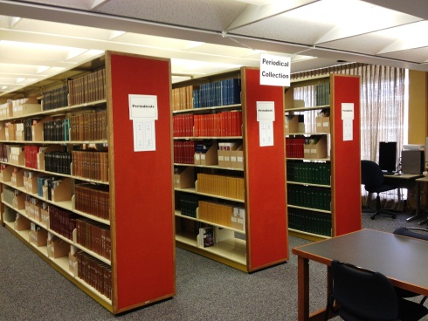 | The Periodical Collection is located in the northwest area of the second floor and includes many professional magazines and journals.
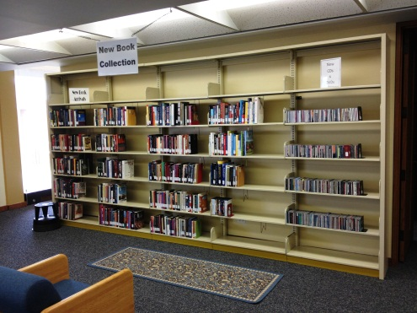 | The New Collection is located at the north east corner of the second floor and contains the newest materials to Magale’s AV and Main Collections. Included are many professional, academic, and popular books, movies, and related resources.
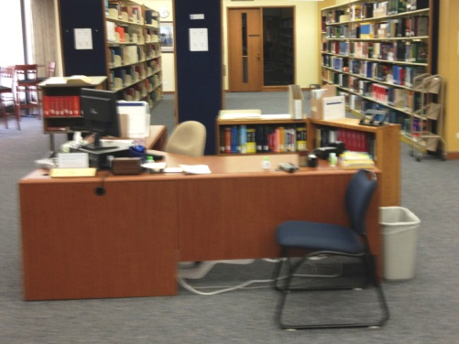 | The Information - Reference Desk is located at the west side of the second floor. It is not only a great place to ask for assistance, it is also the location of many ready-reference materials such as writing manuals, Microsoft how-to guides, and dictionaries.  42

Magale Library Check-Out Policies
University ID or non-university card is required to check out books, other items, and reserves.

How long may I keep the items I’ve checked out?
Books – 28 days
Video Tapes and DVDs – 7 days
Audio Tapes & Books on CD - 14 days
Music CDs & Records – 7 days
Reserves – according to professor’s request
(in-library use only, 1 day, 3 days or 7 days)

How much are fines on overdue books, other items, and reserves?
Books/other items - 10¢ per day past due date
Reserves - $1.00 per hour for every hour overdue.
Student fines and lost fees are paid at the Business office in Overstreet Hall.
Non-university fines and lost book fees are paid at the library
Mon-Thurs. 8 a.m.-4 p.m.

Student records will be put on hold for overdue items.

May I renew items?
- Books/other items – May be renewed once by phone or in person for same period of time as original check out.
- If another patron has requested an item you have checked out, you will not be able to renew it.

What items cannot be checked out?
Reference books
Magazines
Newspapers
Maps

Quick Help
Magale Library employs a staff of reference librarians to help you find information in the library. Reference librarians are on duty Sunday thru Friday during all the hours the library is open.
Give us a call! (870) 235-4170 or email us at library@saumag.edu

Still can’t find what you are looking for?
ASK A LIBRARIAN!

Magale Library Staff Directory
Del Duke  (Magale 220, Ext. 4171) | Interim Director, Instruction/Public Services Librarian – Oversees library’s operations, responsible for all library instruction classes including freshman seminars, library website, computer labs, and Circulation Dept.
Tanya Knight  (Magale 226, Ext. 4172) | Acquisitions Supervisor - responsible for ordering, receiving, paying, and cataloging materials and supplies for the library.
Donna McCloy  (Magale 216, Ext. 4178) | Reference Librarian –responsible for reference area (information desk), interlibrary loan and SAU archives.
Julie Metro  (Magale 228, Ext. 4181) | Electronic Resource Manager –oversees database licensing and access issues.
Peggy Rogers  (Magale 208, Ext. 5066) | Periodicals Librarian - responsible for periodical collections and special projects.
Margo Pierson  (Magale 210, Ext. 4177) | Government Documents and Systems Librarian - responsible for the library’s computer system, technical services.
Debbie Sehon  (Magale 221, Ext. 5068) | Secretary- receptionist; schedules meetings in library classroom and conference room.
Nicole Szadziewicz  (Magale 223, Ext. 4175) | Circulation Supervisor – responsible for overseeing Circulation Dept.
Not sure how to find something or need help with research?
Ask a Librarian!
Email: Library@saumag.edu Phone: 870-235-4170
Also, see helpful library guides and video tutorials on the library’s webpage: web.saumag.edu/library
Other Helpful Contact Information
Information Technology Services Helpdesk
Email: helpdesk@saumag.edu
Phone: (870) 235-4083

Southern Arkansas University
100 East University
Magnolia, Arkansas 71753
Telephone: (870) 235-4000
Homepage: web.saumag.edu

